**FREELANCE JOB MARKETPLACE**

**IMMANUEL ARNOLD DENA (1040474)**

**A PROJECT REPORT PRESENTED TO CATHOLIC UNIVERSITY OF EASTERN AFRICA, FACULTY OF SCIENCE , DEPARTMENT OF COMPUTER SCIENCE, IN FULFILLMENT OF THE AWARD FOR THE DEGREE IN BACHELOR OF SCIENCE IN COMPUTER SCIENCE**

**9th 8, 2024**

**CATHOLIC UNIVERSITY OF EASTERN AFRICA**

**PROJECT PROPOSAL FOR FINAL YEAR STUDY IN COMPUTER SCIENCE**

**BY**

**IMMANUEL ARNOLD DENA (1040474)**

**FREELANCE JOB MARKETPLACE**

**DATE: February, 2024**

Submitted in partial fulfillment of the requirement for the Degree in Computer Science

# DECLARATION AND APPROVAL

**STUDENT**

I, Immanuel Dena, declare that this proposal is my original work and that it has not been presented in any other university or institution for academic credit.

Signature…………………………………...

Date…………………………………………

Student Name …………………....................

Reg_No…………………...............................

**UNIVERSITY SUPERVISORS’ APPROVAL**

This research proposal has been submitted for examination with my approval as University supervisor.

Signature ….………………………… Date …….………………………………

Names………………………………...

Faculty of …………………….............

**HOD APPROVAL**

This research proposal has been submitted for examination with my approval as the University Head of the Department.

Signature .......................................... Date ........................................................

Names ...............................................

Faculty of .............................................

# **ACKNOWLEDGEMENT**

I would like to express my heartfelt gratitude to several individuals and institutions who have contributed to the completion of this project.

First and foremost, I extend my deepest thanks to the Almighty for granting me the strength, perseverance, and guidance throughout this journey.

I am profoundly grateful to my beloved mother for her unwavering support, encouragement, and sacrifices. Her love and belief in my abilities have been a constant source of motivation.

Special appreciation goes to my supervisor, William Mirugi whose invaluable guidance, constructive feedback, and expertise have been instrumental in shaping this project and enriching my learning experience.

Lastly, I am thankful to my fiend Bryan Mureithi and all those who have directly or indirectly contributed to this endeavor. Your assistance, encouragement, and understanding have been indispensable.

Thank you all for being part of this remarkable journey.

**DEDICATION**

This project is dedicated to my dearest mother,for the unwavering love, encouragement, and support you have bestowed upon me throughout my research journey.

# ABSTRACT

*This research aims to design a Freelance Job Marketplace. The proliferation of freelance work in today's economy has led to a surge in demand for efficient platforms connecting freelancers with potential clients. In this digital age, flexible work hours have gained prominence. Now the tradition of 9 to 5 is really dying, as instead of working full time the new generation love to work remotely from home. Today the majority of people are earning money through various online platforms. Modern Technology has consistently changed the working environment and helped workers become more efficient than ever before. This project aims to develop a Freelance Job Marketplace Web Application designed to revolutionize the existing freelance industry by addressing common pain points faced by both employers and freelancers. This project focuses on the development of a Freelance Job Marketplace, a digital platform designed to bridge the gap between skilled professionals and organizations seeking affordable, low-risk human capital. The platform addresses the challenge of professionals needing experience to secure jobs while requiring jobs to gain experience. Built entirely from scratch using PHP, CSS, Hack, HTML, and JavaScript, the marketplace enables companies to hire talent on a short-term basis, reducing legal risks and costs associated with long-term employment. The project serves as a practical solution to modern hiring challenges.*

*The platform acts as a solution to the “chicken-and-egg” dilemma, where jobs require experience, but experience can only be gained through jobs. It empowers graduates and other skilled professionals to showcase their potential, beyond the conventional experience-focused hiring processes, making it easier for them to enter and thrive in their respective industries.*

*The project addresses the inefficiencies and uncertainties of traditional freelance platforms by providing a secure, transparent, and performance-based system.By implementing these features, the project seeks to streamline the process of finding, hiring, and managing freelancers for diverse projects across different domains. Furthermore, the project addresses challenges commonly faced in freelance job marketplaces, such as trust issues, communication barriers, and payment disputes, through robust security measures, real-time communication channels, and transparent transaction mechanisms. The system is designed using a user-centred approach, and the prototype is evaluated through usability testing, including unit testing, integration testing, and end-to-end testing to ensure functionality, performance, and security.. . The development of the platform will utilize HTML, CSS, and JavaScript for the front-end, with PHP facilitating database integration and form validation. MySQL will be employed to create and manage the database, hosted on a MySQL Server, and SQL will be used for database querying. The system will be hosted on a cloud server using Amazon Web Services.Continuous integration and deployment pipelines will be set up to automate the testing and deployment process, ensuring smooth updates and scalability of the system. The ultimate goal of the Freelance Job Marketplace Web Application is to enhance efficiency, transparency, and trust within the freelance ecosystem, facilitating smoother interactions between freelancers and clients while fostering a conducive environment for professional growth and collaboration.*

# Table of contents

Declaration 3

Acknowledgement 4

Dedication 5

Abstract 6

Table of contents 7

List of figures 12

List of tables 14

Definition of key terms 16

Abbreviations 17

Chapter 1: Introduction 18

* 1. Motivation and background 18
  2. Background of research 20
  3. Problem statement 20
  4. Aim of research 21
  5. Objectives of the research 21
  6. Justifications of the research 21
  7. Scope 22
  8. Research organisation 23
  9. Summary of chapter one 23

Chapter 2: Review of related work 24

* 1. Chapter 2 introduction 24
  2. History of the research topic 24
  3. Review of related systems 26
     1. Upwork 26
     2. Fiverr 27
     3. Kuhustle 28
     4. People per Hour 29
     5. Toptal 30
     6. Summary 30
  4. Emerging 31
     1. More internet adoption and usage 31
     2. Remote work 31
     3. Remote hiring 32
     4. Virtual reality and augmented reality 32
     5. Blockchain and cryptocurrency for payment 33
  5. Gap 34
  6. Summary of chapter 2 34

Chapter 3: Research methodology 35

* 1. Chapter 3 introduction 35
  2. Methodology for literature review 35
     1. Websites 35
     2. Research papers 36
     3. Books 36
  3. Methodology for requirement specification 36
     1. Questionnaires 36
     2. Interviews 37
  4. Methodology for system analysis 37
     1. Data Flow Diagrams (DFD) 37
     2. Flow charts 37
  5. System design 38
     1. Database design 38
     2. Process logic 38
  6. System implementation 39
     1. Frontend 39
     2. Backend 39
  7. System testing 39
  8. Methodology for system deployment 40
  9. Chapter 3 summary 40

Chapter 4: System analysis 41

* 1. Chapter 4 introduction 41
  2. Description of the current system 41
     1. System description 41
     2. Strengths 42
     3. Weaknesses 42
  3. Feasibility study 42
     1. Introduction 42
     2. Technical feasibility 43
     3. Economic feasibility 43
     4. Schedule feasibility 45
     5. Social cultural feasibility 45
     6. Legal 46
     7. Feasibility study summary 46
  4. Requirements analysis 47
     1. Functional requirements 47
     2. Non-functional requirements 48
     3. User profile analysis 48
  5. Process logic design of current system 50
     1. Context diagram 50
     2. Data flow diagram 51
     3. Flow charts 51
  6. Chapter 4 summary 56

Chapter 5: System design of the proposed system 57

* 1. Chapter 5 introduction 57
  2. Description of the proposed system 57
     1. Strengths 58
     2. Weakness 58
  3. Conceptual architecture of the proposed system 59
  4. Process logic design of the proposed system 59
     1. Use case diagram 60
     2. Activity diagram 61
     3. Sequence diagrams 63
     4. Class diagram 65
     5. Flow charts 66
     6. Context diagrams 70
  5. Database design 71
     1. Entity Relationship (ER) diagram 71
     2. Normalization 72
     3. Data dictionary 73
  6. I/O of the proposed system 85
     1. Freelancer dashboard mock up 85
     2. Company dashboard mock up 86
     3. Home page mockup 87
  7. Chapter 5 summary 88

Chapter 6: Implementation system & testing 89

* 1. Chapter 6 introduction 89
  2. System screenshots 90
     1. Create job screenshot 90
     2. Jobs list screenshot 91
     3. View job screenshot 92
     4. Admin jobs list report screenshot 93
  3. Testing plan 94
  4. Evaluation plan 95
     1. Project evaluation 96
     2. Outcome Goal 96
  5. Chapter 6 summary 96

Chapter 7: Conclusions, findings & recommendations 97

* 1. Challenges encountered 97
  2. Future recommendations 97
  3. Conclusion 98
     1. Introduction 98
     2. Review of related work 98
     3. Research methodology 98
     4. System analysis 98
     5. System design of the proposed system 98
     6. Implementation system & testing 99
     7. General conclusion 99

References 100

Appendix 103

Appendix: Sample questionnaire 103

Appendix: Budget 105

Appendix: Time schedule 106

Appendix: Sample code 107

# List of figures

Figure I Number of freelance workers in the US from statista.com 25

Figure II upwork.com 27

Figure III fiverr.com 28

Figure IV Kushustle.com 29

Figure V peopleperhour.com 29

Figure VI toptal.com 30

Figure VII Remote work from unsplash.com 31

Figure VIII Virtual Reality’s head-mounted display from marxentlabs.com 33

Figure IX Context diagram 50

Figure X Data flow diagram 51

Figure XI Company create task flowchart 52

Figure XII Freelancer start project flowchart 53

Figure XIII Company complete task flowchart 54

Figure XIV Freelancer complete task flowchart 55

Figure XV Conceptual architecture 59

Figure XVI Use case diagram 60

Figure XVII Give proposal activity diagram 61

Figure XVIII Create task activity diagram 62

Figure XIX Accept proposal sequence diagram 63

Figure XX Create job sequence diagram 63

Figure XXI Give proposal sequence diagram 64

Figure XXII Class Diagram 65

Figure XXIII Company create-task flowchart 66

Figure XXIV Freelancer start project flowchart 67

Figure XXV Company complete task flowchart 68

Figure XXVI Freelancer complete task flowchart 69

Figure XXVII Context diagram 70

Figure XXVIII ER diagram 72

Figure XXIX 1NF 72

Figure XXX 2NF 73

Figure XXXI Freelancer dashboard mock up 85

Figure XXXII Company dashboard mock up 86

Figure XXXIII Home page mock up 87

Figure XXXIV Create jobs screenshot 90

Figure XXXV Jobs list screenshot 91

Figure XXXVI View job screenshot 92

Figure XXXVII Jobs report (In the Admin) screenshot 93

Figure XXXVIII Login view HTML & PHP code 107

Figure XXXIX Freelancers controller PHP code 108

Figure XL Skill model PHP code 109

# List of tables

Table I Economic feasibility 44

Table II User profile analysis 49

Table III client 74

Table IV client index 74

Table V freelancer 75

Table VI freelancer index 75

Table VII freelancer_skill 75

Table VIII freelancer_skill index 75

Table IX job 76

Table X job index 76

Table XI job payment 77

Table XII job payment index 77

Table XIII job payment dispatch 78

Table XIV job payment dispatch index 78

Table XV job propossal 80

Table XVI job proposal index 80

Table XVII job rating 80

Table XVIII job rating index 81

Table XIX job skill 81

Table XX job skill index 81

Table XXI log 82

Table XXII log index 82

Table XXIII reset password token 82

Table XXIV reset password token index 82

Table XXV skill 83

Table XXVI skill index 83

Table XXVII user 83

Table XXVIII user index 84

Table XXIX A sample of tests run 95

Table XXX Budget 105

Table XXXI Time schedule 106

# Definition of key terms

Freelancer - or freelance worker, are terms commonly used for a person who is self-employed and not necessarily committed to a particular employer long-term. Freelance workers are sometimes represented by a company or a temporary agency that resells freelance labour to clients; others work independently or use professional associations or websites to get work.

Client - a person or organization using the services of a freelancer.

Task/Job - a piece of work to be done or undertaken by a freelancer for a client.

Proposal/Bid - An initial document will give a potential client an idea of what services a freelancer is willing to offer them.

Data - Data can be defined as a representation of facts, concepts, or instructions in a formalized manner, which should be suitable for communication, interpretation, or processing by human or electronic machine.

Information - Information is organized or classified data, which has some meaningful values for the receiver. Information is the processed data on which decisions and actions are based.

# Abbreviations

CUEA - Catholic University of Eastern Africa HTML - Hypertext Markup Language

CSS - Cascading Style Sheet JS - JavaScript

PHP - Hypertext Pre-processor SQL - Structured Query Language N/A - Not Applicable

CPU - Central Processing Unit

## Chapter 1: Introduction

### Motivation and background

For many people, Information Technology (IT) is basically synonymous with the people you call when you need help with a computer issue. While that view of information technology isn’t totally wrong, it drastically understates the scope of this critical career field. The most basic information technology definition is that it's the application of technology to solve personal, business or organizational problems on a broad scale. No matter the role, a member of an IT department works with others to solve technology problems, both big and small. A better definition is that Information technology (IT) is the use of computers to create, process, store, retrieve and exchange all kinds of electronic data and information. (“Information technology on Wikipedia”)

Information technology has had overwhelmingly positive effects on our lives today. For example, we have easy, fast and cheap communication. It is easier, faster and cheaper to communicate with a person on the other side of the world today than one trying to communicate with someone in a nearby village a century ago. (Rogers and Forbes, 2019) This allows people and businesses to strengthen interpersonal relationships. It allows easy self-expression for all kinds of people. Additionally, we have great online education and ease of research. Information that was previously locked up in libraries and other expensive sources is now a google search away. People learn art, science and business online via websites like YouTube. A Kenyan athlete, Julius Yego who competes in the Javelin throw during the world Olympics learned how to do that on YouTube. (Bonesteel, YouTube taught javelin thrower Julius Yego wins gold at world championships, 2015.) It has also made it easier to trade. Transactions are much easier and more efficient than they once were. On the consumer side, inventions like the credit card and the emergence of e-commerce have made it easier than ever before for businesses to sell products and services to consumers at their convenience. Foreign transactions like these are much easier now and they may even get easier as the blockchain, which is an emerging technology, gains traction. Healthcare has also been improved by it a lot. We have health apps that track chronic illnesses and communicate vital information to doctors and others that help you track diet, exercise, and mental health information. Virtual reality is also being used to train future surgeons and for actual surgeons to practice operations.

With technology, work has never been easier. Technology in the workplace has helped workers become more efficient than ever before. What used to take hours now can take minutes. Messages can be sent instantly to colleagues or clients across the world. (Jared Spataro and Microsoft 365, 2020) Payments or proposals can be transferred almost immediately. Collaboration is also sometimes simpler to achieve – even when colleagues are not physically in the same place: Teams can hold meetings remotely with video-conferencing technology and work on the same shared documents at once with cloud-based file-sharing tools like Google Drive. The biggest impact of technology in the workplace is in the actual work itself. While most jobs still require you to clock in and work onsite, there are plenty of open positions for people looking to work remotely all over.

You are no longer limited to looking for jobs in your area. Technology has changed both where job-seekers look for work and where companies find talented candidates. (MBO Partners, 2019) You can go to the internet, use any number of job-seeking sites and find remote jobs or positions available to freelancers from anywhere. Companies can hire qualified candidates half a world away if they choose to, and often hire this way for part-time/ contract jobs especially after the COVID-19 pandemic

In many sectors, getting a job has never been easier. Professionals have access to remote jobs from almost every corner of the world. Some examples of these industries are software development, writing, data entry, design, sciences, sales and marketing, accounting, legal services, etc. However, we have a huge number of professionals graduating with high in- demand skills but struggling to get jobs and gain experience. (Ramadhan and Otieno, 2019) It is because the jobs require experience and they require jobs to get experience. Some of these professionals even try but fail to secure unpaid work. This is because most companies need experience. We also have multiple companies and organisations that need such professionals but are afraid of making long term commitments with individuals without sufficient experience due to legal risk and the high cost of managing human capital. Individuals without experience require training and some hand-holding which these companies do not want to do because of the time and financial burden

To overcome this problem, a freelancing marketplace can be created that will connect talented individuals with economic opportunities and help organisations cut down on the cost of managing human capital by getting individuals to work for them on a short-term basis.

### Background of research

In Kenya, we have large numbers of professionals complaining that they cannot get jobs. These professionals are graduating with skills in software development, writing, data entry, design, sciences, sales and marketing, accounting, legal services, etc. They, however, struggle to get started and gain experience in such high-in-demand industries. It is because the jobs require experience and they require jobs to get experience.

Companies also claim that they are struggling to find skilled professionals. (Roussi and Financial Times, 2021) We have multiple companies and organisations that need the above- mentioned professionals but are afraid of making long term commitments with individuals without sufficient experience due to legal risk and the cost of managing human capital.

To overcome these problems, a freelancing marketplace can be used. It will connect talented individuals with economic opportunities and help organisations cut down on the cost of managing human capital by getting individuals to work for them on a short-term basis. This is already being used in Europe and in the USA wherein 2019, an MBO Partners’ survey found that nearly 41.1 million Americans identified themselves as freelancers, whether it was a few hours a month or a full-time arrangement. To break that down a little further, nearly 15 million workers claimed to be part-time freelancers, and 12.4 million called themselves full-time freelancers! (MBO Partners, 2019)

### Problem statement

We have a huge number of professionals graduating with high in-demand skills. They, however, struggle to get started and gain experience in these industries. Jobs require experience and they require jobs to get experience. A sort of chicken-and-egg problem. The technology used in the hiring and selection process is not optimised to showcase their potential. It majorly focuses on experience. We also have multiple companies and organisations that need such professionals but are afraid of making long term commitments with individuals without sufficient experience due to legal risk and the high cost of managing human capital. To overcome this problem, a digital freelancing marketplace can be created that will connect talented individuals with economic opportunities and help organisations cut down on the cost of managing human capital by getting individuals to work for them on a short-term basis.

### Aim of research

Create a digital freelancing marketplace that will connect talented professionals with economic opportunities and give organisations access to affordable and low-risk human capital.

### Objectives of the research

The main objective is to create a freelancing marketplace that will connect talented individuals with economic opportunities and help organisations cut down on the cost of managing human capital in Kenya. This will be achieved by the following specific objectives:

* + 1. To review related marketplaces built for use in Europe and the USA. Then identify their strengths and weaknesses.
    2. To explore the known existing research done and unlock unknown possibilities of the research.
    3. Develop a logical design for the proposed system.
    4. To create a user interface design, database design, UML diagrams and a conceptual architecture for the proposed system.
    5. To implement and test the system and come up with an evaluation plan.

### Justifications of the research

In Kenya, we have around 30000 graduates each year. (Ramadhan and Otieno, 2019) These graduates are mostly young and hungry, looking for places to get experience and hopefully earn an income. The traditional job pool cannot handle these huge numbers year after year. Even if it could, companies are mainly looking for experienced professionals. The technology used in the hiring and selection process is not optimised to showcase their potential. It majorly focuses on experience. This problem can be solved by having a framework in which these graduates can get some experience without necessarily getting full-time employment. Maybe working part-time or on a need-to basis for companies in need of a particular skill.

Organisations in Kenya are struggling to find skilled, talented and experienced candidates to fill in job slots. This is being made worse by multinationals like Microsoft that are also trying to recruit such staff and offering them around 5X the average salaries. It is getting increasingly difficult to hire new talent as the heavyweights take the best candidates out of the market. (Roussi and Financial Times, 2021) This is leading to companies spending a lot of money on recruitment and retainment, raising the costs of managing human capital. All this is happening

while the job market is flooded with recent graduates (that are inexperienced). We can help these companies relieve their staffing pressure by giving them access to a low cost and low- risk pool of candidates. These candidates can start working part-time on non-critical work as they get the necessary experience then maybe get full-time employment once the experience level is what is needed by the companies.

We have around 6.378 billion smartphones in the world. (Turner and Bank my cell, 2021) These phones have had countless applications in medicine, education, research and even military use cases. Many people can’t spend one hour without looking at their phones and laptops. We can use these devices to our advantage. The unemployed can use these devices while at home to do tasks for companies. This will both be a source of income to the unemployed and will relieve the human labour costs for the companies involved.

### Scope

The scope of the project is as follows:

* + 1. Allow freelancers to have online profiles.
    2. Allow freelancers to be paid via easy methods like M-Pesa.
    3. Money to be held in escrow to help in preventing fraud.
    4. Allow companies, organisations and individuals (job posters) to post jobs.
    5. Allow the job posters to receive bids on the job from qualified freelancers.
    6. Allow the job posters to review freelancer profiles to help them with the selection.
    7. After selecting they work in a virtual office with specific milestones tracked where key deliverables are structured until delivery.
    8. Ratings and reviews for both clients and freelancers after jobs.
    9. Notifications. The system should be able to notify the freelancers and job posters of actions that require their attention.
    10. Dispute resolution after project completion and payment between the clients and applicants to be done by staff within the system.
    11. Admin section and Generation of reports. There should be an admin app that can be used to manage customers, freelancers and postings. There will be reports like jobs posted, payments gone through, etc.

### Research organisation

Chapter 2 will consist of a detailed literature review of similar papers and we will discuss the aims, objectives, and other solutions of other authors that had simulated or built similar marketplaces. Chapter 3 focuses on the design methodology used to accomplish the project and the software implementations of the designs are discussed in this chapter. While chapter 4 will involve the description of the current systems, their strengths and weaknesses plus their feasibility study. In chapter 5, we will focus on the design methodology used to accomplish the project. Chapter 6 will deal with the implementation system & testing: the system will be implemented and we will figure out how it will be tested. Chapter 7 summarizes the project in conclusions, limitations, and future works of the project.

### Summary of chapter one

In this chapter, we provided a brief overview and background of our research topic. We saw why the research is needed and provided some objectives and the scope it will cover.

## Chapter 2: Review of related work

### Chapter 2 introduction

The main aim of this chapter is to review research related to freelance and work as well as go through companies that offer freelance marketplaces seeing their features and critique them. It will involve a deep entry into the field, going to search engines and input some of the keywords related to your project. The goal of this is to give an entry into the field and traverse the past looking at how similar projects have fared. This is done till we understand the development of the field and how the field progressed over time.

### History of the research topic

Freelancers might be defined as those genuinely in business on their own account, working alone or with co-owning partners or co-directors, responsible for generating their own work and income, but who do not employ others; Freelancers operate under a range of legal business forms: as self-employed sole proprietors or partners in unincorporated businesses, as directors of their own limited companies. (Are Freelancers a Neglected Form of Small Business?, 2012) Research is "creative and systematic work undertaken to increase the stock of knowledge". It involves the collection, organization and analysis of information to increase understanding of a topic or issue. A research project may be an expansion of past work in the field. To test the validity of instruments, procedures, or experiments, research may replicate elements of prior projects or the project as a whole. (Wikipedia)

The automation of many labour-based tasks using robots etc. allowed companies to focus on more creative and technical tasks. As these companies grew in size, they began to have employees from all over the world at different time zones who needed to collaborate. They had to work remotely via internet calls and chats. This allowed companies to also hire remotely and this gave them a huge pool of candidates. This allowed them to hire professionals who only come in on a short-term basis working on work on one task or another also known as Freelancers.

Our earliest written evidence for 'freelance' comes from Sir Walter Scott's Ivanhoe, in which a lord refers to his paid army of 'free lances'. When freelance first came into English in the early 1800s, it was used to refer to a medieval mercenary who would fight for whichever nation or person paid them the most. (Merriam Webster)

As the Internet developed in the late 60s, these workers started connecting with each other for a particular job. Today, almost everyone has access to the Internet making easier for freelancers and clients to connect. With the increase of freelance platforms, the competition is tougher than ever. Freelancers can explore the different platforms and clients can search for platforms that have the lowest fees.

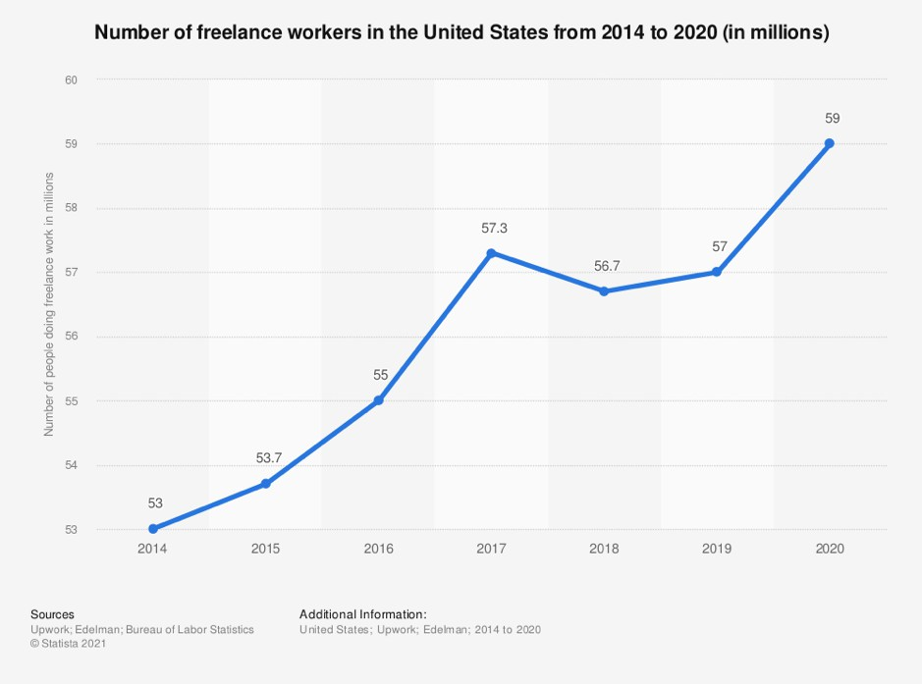

*Figure I Number of freelance workers in the US from statista.com*

It is clear that freelancers existed before freelancing platforms existed. However, it is difficult to say which the first freelance platform was, as there are some big freelancing platforms that merged with other sites, or were bought out by other sites. For example, Elance was probably one of the earliest sites - being founded in 1999, and oDesk in 2003. These sites then merged to form Upwork in 2013. PeoplePerHour started up in 2007. Freelancer started in 2009 and purchased other freelancing sites, some of which were founded back in 2001 and 2004. It’s fair to say that these freelancing platforms made freelancing a possibility for the masses in Europe and the USA, and created the huge marketplace for all types of work that we see today. What we know is that freelancing is growing at an incredibly fast rate. In 2020, there were 59 million people doing freelance work in the United States. This is an increase from 2014, when there

were about 53 million people freelancing. The number of freelancers in the U.S. has been increasing since 2014. (Statista, 2020)

### Review of related systems

#### Upwork

Upwork (Upwork), a platform created by combining the former Elance and ODesk platforms, lets you find your next favourite freelancer by either searching for candidates on the site or posting a job and letting people apply. It is mainly used in Europe and the USA. Once you’re set-up, you will likely be impressed with the wide range of freelancer skills and prices on the site. The platform makes it easy to work with freelancers – you can schedule chats, send messages, exchange files, and give feedback. One major problem is the job posting process that seems to be a bit complicated – you have to set up your company and then fill out an eight- page form. Another issue is that there seems to be a lot of spam. Task postings get a lot of low quality and unrelated applications.

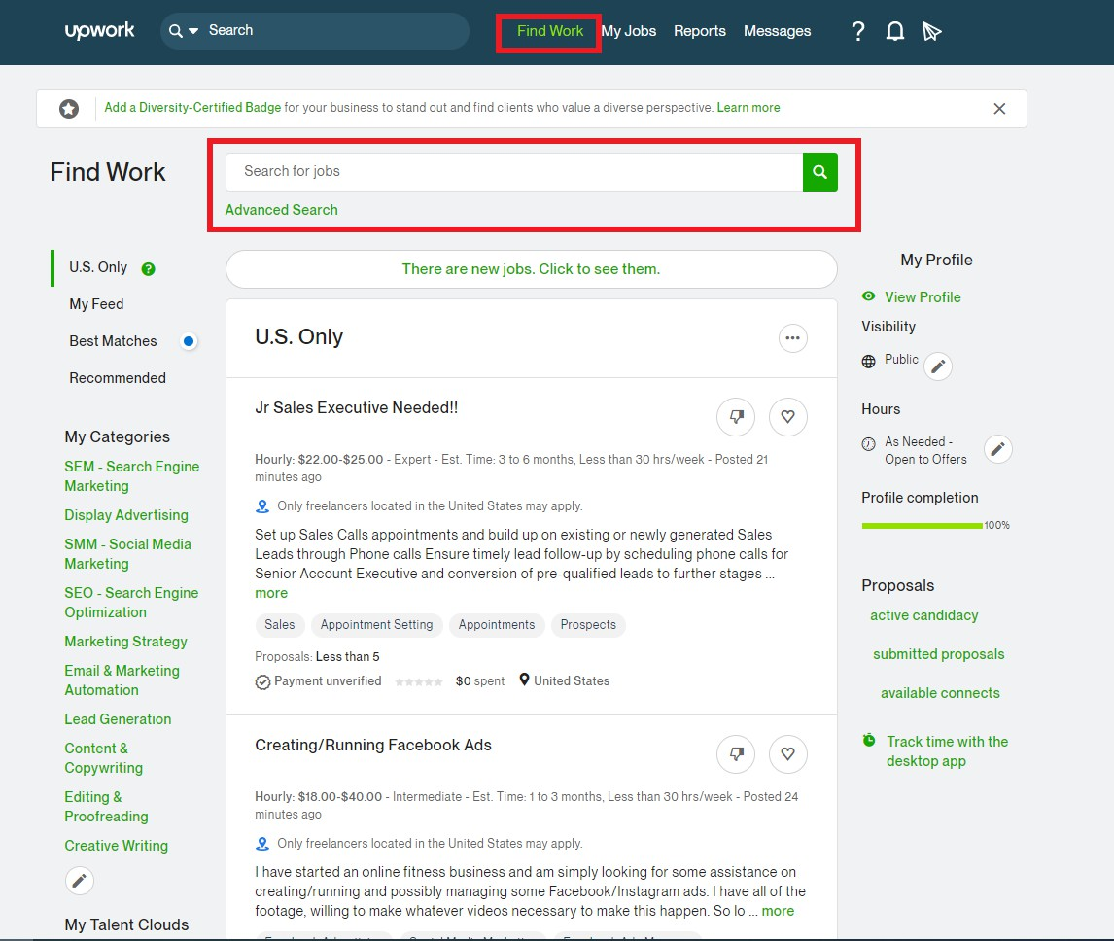

*Figure II upwork.com*

#### Fiverr

Fiverr (Fiverr) is a platform that connects freelancers with business owners looking for services in various digital projects, including website design, content writing, and voice-overs mainly in the US. Instead of sending out bids, sellers can sign up for free, list their gigs, and set their prices. Meanwhile, buyers can simply browse through different categories to purchase. This mostly favours big projects. Whenever a buyer purchases a gig, the system automatically charges their account and puts the money on hold. The system will then take a commission fee and send freelancers 80% of the offered price. Depending on each freelancer’s seller level, it can take up to 14 days to withdraw their earnings. There are multiple options to withdraw the payments, such as debit card, PayPal, and wire transfer. Some of the shortcomings are that it is very difficult to track milestones and dispute resolution is almost non-existent.

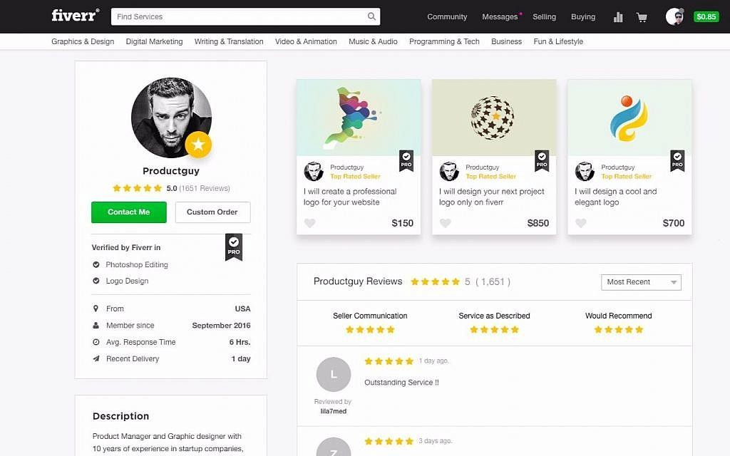

*Figure III fiverr.com*

#### Kuhustle

A review of the most common marketplaces in Europe and the USA shows a major problem: They do not support Kenyan payment methods. Common payment methods like M-Pesa and Equitel that the regular Kenyan uses are not available. Locally, the research was able to find only one major freelancing site: Kuhustle (kuhustle). Some of the problems are that; that

applicants have to pay in order to bid and it has a bad user interface.

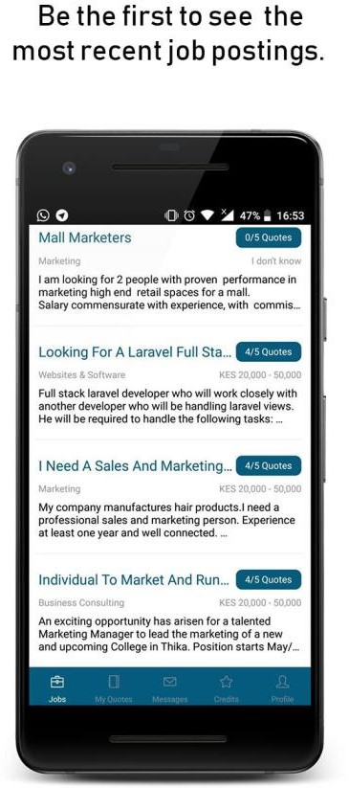

*Figure IV Kushustle.com*

#### People per Hour

People per Hour is relatively smaller as compared to Fiverr and Upwork but still large enough to be talked about. It is located in the US and the major goal of people per hour is empowerment. They want to empower freelancers to make money. However, it pays really low, the reviews system doesn’t seem to work well, does not support a lot of common payment methods and the quality of jobs is very low.



*Figure V peopleperhour.com*

#### Toptal

Toptal (Toptal) is a professional freelancing marketplace focusing on software engineering. It is headquartered in the USA. If you have a lot of money to spare and looking for the top 2% of freelance talent on earth, then you might need to look at Toptal. At Toptal, you will find the top 2% of the world’s best freelancing software engineers. However, it is very expensive, does not support Kenyan payment methods and has a very long onboarding process for freelancers.

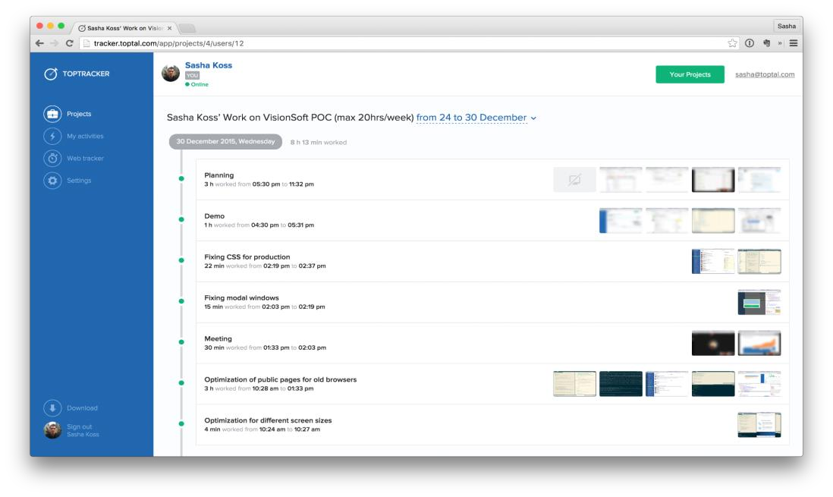

*Figure VI toptal.com*

#### Summary

The above platforms shadow similar problems. For example, they are bloated and have too many features. It might be better to focus on the most needed features. They often have a complex interface and are not easy to use. As a result of the point above and other reasons, they often come with complicated tutorials with instructions that take time to learn. They often charge high service/commission and have a long payment process. Some even charge freelancers when applying! A lot of fake spam applicants and fake clients are on the platforms. This is especially common for low paying tasks.

### Emerging

#### More internet adoption and usage

The internet is becoming very instrumental to our modern-day lives. From free international internet calls, fleet management- where companies know where and how fast their cars are going to intelligent sensors with extensive use cases in agriculture and even water plus electricity supply management through IoT. Their use cases are also trickling down to homes and to the individual (e.g.: e-commerce, social media, smart glasses, fitness bands, etc.) and companies worldwide. People are using internet apps to control smart homes with automatic lights, smart security systems, and smart appliances.

#### Remote work



*Figure VII Remote work from unsplash.com*

There is also a huge uptake in remote working. (MBO Partners, 2019) The COVID-19 pandemic forced small, medium, and large enterprises to adapt quickly to remote working. Work will probably never be the same as it was before. While some companies quickly adopted remote work during the pandemic, others embraced it slowly and reluctantly. Going forward businesses will likely have remote working as a key tool to maintain business continuity. All of these was enabled by the low cost computers and internet that people have access to.

Remote work is here to stay, whether mandated by employers or due to employees' personal choices. Satya Nadella, the Microsoft CEO, shared some staggering numbers in April 2020. They saw more than 200 million Microsoft Teams, a remote coworking video service, meeting participants in a single day, generating more than 4.1 billion meeting minutes. Also, Teams now has more than 75 million daily active users, and two-thirds of them have shared, collaborated, or interacted with files on Teams as well. As Satya put it, “We’ve seen two years’ worth of digital transformation in two months. From remote teamwork and learning to sales and customer service, to critical cloud infrastructure and security—we are working alongside customers every day to help them adapt and stay open for business in a world of remote everything.” (Jared Spataro and Microsoft 365, 2020)

#### Remote hiring

Most organizations have transitioned to remote work in response to the coronavirus pandemic and having a completely virtual onboarding process of new hires. This has attracted a lot of candidates to those companies and a lot of people are taking up these remote jobs. A FlexJobs survey taken by over 4,600 people between July and August of this year found that almost half of the respondents said they knew someone who has quit or is planning on quitting their job because they were asked to return to the office. Of those surveyed, 58 per cent said they want a fully remote job post-pandemic—only 3 per cent said they wanted to return to the office full- time. (Real Simple and Srinivasan, 2021)

#### Virtual reality and augmented reality

Virtual Reality is the use of computer technology to create a simulated environment. (Bardi, 2019) Virtual Reality’s most immediately-recognizable component is the head-mounted display (HMD). Human beings are visual creatures, and display technology is often the single biggest difference between immersive Virtual Reality systems and traditional user interfaces. Augmented reality (AR) is the real-time use of information in the form of text, graphics, audio and other virtual enhancements integrated with real-world objects. It is this “real world” element that differentiates AR from virtual reality. AR integrates and adds value to the user’s interaction with the real world, versus a simulation. (Gartner, 2020)



*Figure VIII Virtual Reality’s head-mounted display from marxentlabs.com*

Fully immersive and increasingly realistic, its advances in technology have increased accessibility while reducing development costs are starting to open up huge possibilities in fields as diverse as retail, healthcare, education, tourism, and journalism. Initially seen as something of a curiosity, AR devices overlay information, graphics or audio content to the user’s experience of their real-world environment, with sometimes dramatic impact. These tools enable teams working separately to feel like they are in the same room.

#### Blockchain and cryptocurrency for payment

Blockchain technology is a distributed ledger system that promotes decentralization, transparency, and data integrity. (Iredale) Blockchain is a type of shared database that differs from a typical database in the way that it stores information; blockchains store data in blocks that are then linked together via cryptography. As new data comes in, it is entered into a fresh block. Once the block is filled with data, it is chained onto the previous block, which makes the data chained together in chronological order. Different types of information can be stored on a blockchain, but the most common use so far has been as a ledger for transactions.

A cryptocurrency is a digital or virtual currency that is secured by cryptography, which makes it nearly impossible to counterfeit or double-spend. (Frankenfield, 2022) Many cryptocurrencies are decentralized networks based on blockchain technology. A defining

feature of cryptocurrencies is that they are generally not issued by any central authority, rendering them theoretically immune to government interference or manipulation.

This technology has already made a name for itself as the technology behind the virtual currency, Bitcoin, but its significance goes beyond virtual currencies to traditional financial services and beyond. Offering unprecedented levels of accuracy, traceability, reliability and security to any number of transactions and interactions, Blockchain offers the potential to cut costs too. This will allow team distributed all over the world to have an easy trusted method of payments.

### Gap

The system being built will be easy and intuitive to use. It will not require training / a manual and the app will be intuitive to use. The research will focus on the most needed features and have an intuitive user interface. It will have Kenyan payment methods. Common payment methods like M-Pesa and that are available to the regular Kenyan. The service fees will be extremely affordable. Task applicants will not be charged to apply. Companies will not be charged to post. The commission will only be charged on transactions. Applicants will only receive payment 24 hours after service delivery to ensure fake ones are weeded out. The clients will also have to pay before posting and their money to be held in escrow to ensure they are not fake. The payment can be refunded if not satisfied with the service.

### Summary of chapter 2

In this chapter, we have seen the past and current state of the work done in our research area. Though there are some digital marketplaces, we have seen that they do not cater for the regular Kenyan graduate and may be very complicated to use.

## Chapter 3: Research methodology

### Chapter 3 introduction

Methodology in research is defined as the systematic method to resolve a research problem through data gathering using various techniques, providing an interpretation of data gathered and drawing conclusions about the research data. Essentially, a research methodology is the blueprint of a research or study. (S. N. Murthy, 2009)

This chapter addresses research methods and tools to be used during the research and system development in order to achieve the above aim. It will explain the different techniques, reference materials and tools that will be used to carry out the research, together with the reasons behind their use. A brief summary of each stage of the software implementation will be explored together with their benefits.

### Methodology for literature review

A literature review is an overview of the previously published works on a specific topic. The term can refer to a full scholarly paper or a section of a scholarly work such as a book, or an article. Either way, a literature review is supposed to provide the researcher/author and the audiences with a general image of the existing knowledge on the topic under question. (Beevil, 2021)

It consists of studying and providing a critique on existing material on the research topic to be covered and deriving connections from the materials. The research will go through materials in the date range of the years 2000 – 2022 like books, recent research on such systems as well as an overview of other similar websites in Europe and the USA. The main sources are discussed below:

#### Websites

The research aims to look at some of the most popular websites currently being used. This will allow us to see the kinds of jobs posted and the problems these companies face. The main platforms we aim to look at are; Fiverr https://[www.fiverr.com,](http://www.fiverr.com/) Upwork https://[www.upwork.com](http://www.upwork.com/) and Kuhustle https://[www.kuhustle.com](http://www.kuhustle.com/) from Kenya.

#### Research papers

Content will also be sourced from official of research papers related to the research. Example; Oo, B.L., Lo, H.P., & Lim, B.T. (2012). The effect of bidding success in construction bidding. Engineering, Construction and Architectural Management, 19, 25-39. This paper aims to examine the impact of a winning bid on contractors' bid pricing strategies.

#### Books

Books tend to have very in-depth content on specific topics and will be important to the research. Here are some the books that we will go through:

* + - 1. Sara Horowitz, Toni Sciarra Poynter. The Freelancer's Bible: Everything You Need to Know to Have the Career of Your Dreams on Your Terms. Workman Publishing Company, 2012.
      2. Steve Krug. Don't Make Me Think, Revisited: A Common-Sense Approach to Web Usability (3rd Edition) (Voices That Matter) 3rd Edition. New Riders, 2013.
      3. Martin Kleppmann. Designing Data-Intensive Applications. O'Reilly Media, Inc, 2017.

### Methodology for requirement specification

#### Questionnaires

It contains a list of survey questions that are asked to respondents, designed to extract specific information. It serves four purposes: collect the appropriate data, make the data comparable and amenable to analysis, minimise bias in formulating and asking questions and make questions engaging.

The reason questionnaires are chosen is because of the low cost and ease of collecting the data. Questionnaires can be open-ended where the researcher provides a list of possible answers to choose from or closed ended where the respondents just answer with their own words.

The research will use closed ended questionnaires as the data will be easier to process and the questionnaires faster to fill. It will be conducted by sharing questionnaires with professionals in communities around us. We aim to have around 50-100 respondents fill them via an online form. The forms the research will use are from Google forms.

#### Interviews

Face to face interviews have the advantage of the interviewer to establish a rapport with the interviewees hence a gain their cooperation. They also provide higher flexibility to the interviewers and the interviewer can judge the non-verbal behaviour of the respondents.

We aim to do around 10 face to face interviews with working professionals. The motive is to help us get a more direct feel of the problems they undergo plus allow us to ask follow-up questions related to the respondents’ answers and behaviour.

### Methodology for system analysis

Systems analysis is a problem-solving method that involves looking at the wider system, breaking apart the parts, and figuring out how it works in order to achieve a particular goal. (Wood, 2021)

#### Data Flow Diagrams (DFD)

A data flow diagram (DFD) is a visual representation of the information flow through a process or system. DFDs help you better understand process or system operation to discover potential problems, improve efficiency, and develop better processes. They range from simple overviews to complex, granular displays of a process or system. (Chi, 2021)

Data Flow Diagrams will be used present a flow of data within the different processes of the system. They will be key in describing the processes that are involved in the system while transferring data from the input to the file storage and even for generating reports.

Data Flow diagrams were chosen since they are straight forward and are simple to understand.

#### Flow charts

A flowchart is a picture of the separate steps of a process in sequential order. It is a generic tool that can be adapted for a wide variety of purposes, and can be used to describe various processes, such as a manufacturing process, an administrative or service process, or a project plan. (ASQ Org, 2021)

Flow chart will be useful because it will be demonstrating the graphical diagram which will present the sequence of steps to solve the problems, breaking down the complex process into simple steps that will be connected by arrows.

### System design

#### Database design

An Entity Relationship Diagram Finally will be used to offer a visual representation of how data will be organised in the database. This is because ERD diagrams are not only simple to understand but are also more flexible and allow the data model to be altered with minor disruptions to the schema.

#### Process logic

Data Flow Diagrams will be used to demonstrate how information is transferred within the different processes of the system. They will be key in describing the processes that are involved in a system to transfer data from the input to the file storage and even for generating reports. Data Flow diagrams were chosen since they are straight forward and are simple to understand.

* + - 1. Unified Modelling Language (UML)

Unified Modelling Language (UML) is a general-purpose modelling language. The main aim of UML is to define a standard way to visualize the way a system has been designed. It is quite similar to blueprints used in other fields of engineering. (GeeksForGeeks, 2019)

UML will be used to produce models and diagrams of the system at different levels by presenting different perspectives of the system, it will intend to provide a standard way to visualize the design of the proposed system.

* + - 1. Use case diagrams

A UML use case diagram is the primary form of system/software requirements for a new software program underdeveloped. Use cases specify the expected behaviour (what), and not the exact method of making it happen (how). Use cases once specified can be denoted both textual and visual representation. (Visual Paradigm)

A key concept of use case modelling is that it helps us design a system from the end user's perspective. It is an effective technique for communicating system behaviour in the user's terms by specifying all externally visible system behaviour.

The use case diagrams will used in identifying, clarifying and organizing the system requirement on how the system will be performing the tasks by making a set of possible sequences of the interactions between systems and users.

### System implementation

#### Frontend

HTML (the Hypertext Markup Language) and CSS (Cascading Style Sheets) are two of the core technologies for building the frontend. HTML provides the structure of the page, CSS the (visual and aural) layout, for a variety of devices. These technologies are chosen because they are the standard for frontend website development. We will also use JavaScript to make the site interactive.

#### Backend

The backend will use PHP. PHP was chosen for its compatibility and ability to work seamlessly with HTML. PHP code can easily be embedded in HTML pages as well as process form data collected from HTML pages by storing and retrieving such data to and from a database.

PHP language was chosen because of its widespread use at a global scale with multiple web browsers compatibility across various software platforms and various end user devices.

The database will be MySQL. It is a relational database management system (RDBMS), which means it stores records in multiple, separate, and highly codified tables rather than a single repository. Some of the reasons for using it are; it is the most popular database, it is open source, is a fast database, it can scale to meet the website’s demand and is generally secure. phpMyAdmin is a free and open-source administration tool for MySQL and MariaDB databases. It is used to interact with the database and it acts as a local host environment while testing and implementing the system. phpMyAdmin has a Database GUI module that helped develop the database using SQL (Structured Query Language). phpMyAdmin was selected for its ability to run SQL queries through its GUI.

### System testing

Testing helps in determining the success level of the system developed, helps to make the system bug and error free, can help the developer to meet all the user requirements in the most efficient manner and improves the consistency of the developed system.

The developer alone should not be the only person to test the system. There are certain testing standards which are fulfilled only when other users conduct the test for the system as users other than the developer can easily discover the data input and output errors in using the system.

The testing of the system will be done by asking professionals around us to sign up and try it out. The research will also try to get companies owned by my friends and relatives to hire from the platform. We aim to get 2 companies on the platform plus 10-20 freelancers. They will fill in a questionnaire after that.

### Methodology for system deployment

The system deployment will be of a cutover/big bang at every point in time. All the users move from one system to another at the same time on a given date. This is to ensure quick implementation time, lower costs and only one system at a given point in time.

### Chapter 3 summary

In this chapter, we have covered what we are going to do during the research and system development. It provides a detailed description of how the entire research will be carried out. The different stages of the research together with the tools and techniques employed in the process will be provided together with a detailed explanation and justification of the methodology chosen.

## Chapter 4: System analysis

### Chapter 4 introduction

Here, we take a deep dive into the system being improved and the current systems. An overview of how the system works, the different components of the system and the different roles played by each component will be examined. This chapter also looks at the strengths and weaknesses of the system together with the functional and non-functional requirements of the system among many others requirements. By the end of this chapter the research aims to have gained a thorough understanding of the system before moving on to how to improve it in the future.

### Description of the current system:

#### System description

With the rise in the use of the internet as a medium to helping us enhance the way we do business; it has also revolutionized the way a job search is done. But, even with this, traditional methods like manual job applications, classified newspaper advertisements, network of the people around you, phone book directories, and such still play role in job seeking. People find job postings and apply manually to these companies. This might involve manually submitting your curriculum vitae or resume, the company hiring going through potentially thousands of physical documents, making follow-ups to the candidates though letters and phone calls. Most of these steps also involve a lot of repetition e.g.: photocopying documents and physical record keeping that might be inefficient.

It’s estimated that 60% of job openings are never advertised, filled before posted or published to the public; they are filled from internal postings, through networking and resumes on file. Many success stories are using this method, but it takes time, effort, and needs to be done effectively. (Thomas, 2019) This can also introduce a lot of bias.

However, you are no longer limited to looking for jobs in your area. Technology has changed both where job-seekers look for work and where companies find talented candidates. (MBO Partners, 2019) You can go to the internet, use any number of job-seeking sites and find remote jobs or positions available to freelancers from anywhere. Companies can hire qualified candidates half a world away if they choose to, and often hire this way for part-time/ contract jobs especially after the COVID-19 pandemic. In many sectors, getting a job has never been

easier. Professionals have access to remote jobs from almost every corner of the world. Some examples of these industries are software development, writing, data entry, design, sciences, sales and marketing, accounting, legal services, etc. All of this is powered using online freelancing marketplaces.

#### Strengths

Here are some of the advantages of traditional physical job applications:

* + - 1. Gaining early consideration for a position that has not yet been advertised through personal referrals. (Thomas, 2019)
      2. A fixed baseline salary that most companies can't decrease without cause.
      3. Being part of a company’s upcoming expansion plans.
      4. Increase your network of contacts and having your resume forward on for more possible considerations.
      5. Long term contracts/work.
      6. No commission charged on the payment of the worker by a middleman.

#### Weaknesses

Here are some of the weaknesses of physical job applications:

* + - 1. Lack of work-life balance and control over your schedule: work takes up a huge chunk of time.
      2. Most of time work has a geographic limitation in the form of an office.
      3. Do not appeal to millennials. Today’s millennials do not want to be saddled with the boring grind of traditional 9-to-5 work. They want the freedom to work at their own pace and observe a good balance between their professional and personal lives.
      4. Lower range of applicants reached compared to other methods leveraging the internet.
      5. Long recruiting cycles.

### Feasibility study

#### Introduction

A feasibility study is simply an assessment of the practicality of a proposed project plan or method. This is done by analysing technical, economic, legal, operational and time feasibility

factors. Just as the name implies, you’re asking, “Is this feasible?” For example, do you have or can you create the technology to do what you propose? Do you have the people, tools and the resources necessary? And, will the project get you the ROI you expect? (Bridges, 2021)

#### Technical feasibility

This assessment focuses on the technical resources available to the organization. It helps organizations determine whether the technical resources meet capacity and whether the technical team is capable of converting the ideas into working systems. Technical feasibility also involves the evaluation of the hardware, software, and other technical requirements of the proposed system.

During the study, it was found out that the best system will be a complete web-based application. This is to make it greatly accessible to many people. The main technologies and tools that are associated are HTML, CSS, JavaScript, PHP and PostgreSQL. Each of the technologies are available locally, are free, are open source and the technical skills required are within the developer’s capabilities.

It was also seen that the website can be hosted in a free web hosting space, but for later implementations it will be hosted in a paid web hosting space with a simple server with 2 processors and 2gb RAM. This will be sufficient to handle high traffic. It will then be accessed via the internet using the users’ smartphones or computers on a 2G or 3G. Nothing new here, this is technology that has been working for decades. Internet is also affordable for the target market.

It's clear that the project is technically feasible.

#### Economic feasibility

This assessment typically involves a cost analysis of the project, helping determine the viability, cost, and benefits associated with a project before financial resources are allocated. It also serves as an independent project assessment and enhances project credibility.

Being a web application, the system will have an associated hosting cost. Since the system doesn't consist of any multimedia data transfer, bandwidth required for the operation of this application is very low. The system will follow the freeware software standards. No cost will be charged from the potential customers. Bug fixes and maintaining tasks will also have no associated cost. The table below show this in more detail.

|  |  |  |
| --- | --- | --- |
| **Feature** | **Total Cost in Kenyan**  **Shillings** | **Benefit in Kenyan Shillings** |
| Domain registration | 1200 – one-time payment | Possibly millions of users will be able to find it easily via the internet. This will save the company 10000+  per year in recruiting costs. |
| Web hosting | 6000 - per year | Make the website fast and accessible via the internet. This will save the company 10000+ per year in manual  filing costs. |
| Initial development hardware including electricity costs over the  development period | 800 – one-time payment | Build the complete system. |
| Maintenance | 12000 – per year | Fix bugs and ensure the system is running for the users. This will save the company 10000+ per year compared to hiring fulltime human resources staff to maintain a larger human  resources department. |

*Table I Economic feasibility*

For the companies hiring freelancers; hiring traditional full-time employees are expensive. In addition to paying their salary, business owners are responsible for training costs, benefits, health insurance, paid time-off, and payroll taxes. In contrast, hiring a freelancer allows your business to eliminate many of these overhead costs. Freelancers don’t require a dedicated workspace in your office or training. Hiring a freelancer allows a business to reduce costs without sacrificing work output.

From these it's clear that the project is financially feasible.

#### Schedule feasibility

This assessment is the most important for project success; after all, a project will fail if not completed on time. In scheduling feasibility, an organization estimates how much time the project will take to complete. This project’s documentation and coding will take around eight months that is available.

#### Social cultural feasibility

During the study we encountered a problem that we had to solve. How can the system be halal? The main two issues for halal online businesses are the type of contract a buyer and a seller are agreeing on and the type of payment that is done for a transaction. According to most Muslim scholars, there are — in general — four pillars of a contract that must be fulfilled, which are offer (ijab) and acceptance (qabul), two contracting parties, subject matter and the mode of expression (sighah). In other words, for a transaction to become halal, an offer has to made by the first party on the Internet. Then, the second party is given the freedom of acceptance to enter into the contract. The offer and acceptance must be clear and confirmed by both parties. The subject matter - the product or service - must be beneficial and lawful in Islam, valuable, under possession, in existence and deliverable. (Maierbrugger, 2018) All of this will be enforced by the system.

Many companies have projects which they give either to outside contractors or to some other organization so that they can save their employee's time and utilize them in something more productive. When you hire a full-time employee, you invest in that individual’s future with the company. Training and onboarding them costs money and time, which generally involves some risk. Rather than losing that investment if the employee decides to leave the company, working with a freelancer allows you to build a contract with specific deliverables before payment. Working with a freelancer also reduces the risk as you can make changes without impacting your internal processes.

Remote work is here to stay, whether mandated by employers or due to employees' personal choices. Satya Nadella, the Microsoft CEO, shared some staggering numbers in April 2020. They saw more than 200 million Microsoft Teams, a remote coworking video service, meeting participants in a single day, generating more than 4.1 billion meeting minutes. As Satya put it, “We’ve seen two years’ worth of digital transformation in two months. From remote teamwork and learning to sales and customer service, to critical cloud infrastructure and security - we are working alongside customers every day to help them adapt and stay open for business in a

world of remote everything.” (Jared Spataro and Microsoft 365, 2020). Companies are willing to work with freelancers.

51% of freelancers say no amount of money could convince them to take a full-time job. 75% are optimistic about the future of their work. These are just a couple statistics powering the shift from full time employment to remote project-based work we call the freelance economy. (Pearce, 2019) Some of the reasons individuals prefer freelancing are; can be done on the side around your job, it's a way to generate extra income to pay off debt or save for a rainy day, it's affordable to start if you already have the skills and equipment to do the job, you can start quickly, as soon as you find a client, you can start getting paid to freelance, it allows for greater independence over a job, it's often flexible, allowing you to work part-time or during off- business hours.

#### Legal

According to the Data Protection Act Kenya, data controller is a ‘natural’ or ‘legal’ person, agency, public authority or other body, which has the power to determine, either alone or with others, the purpose and means of processing of personal data. In this case we will be a data controller.

In order to comply with the law, we will have to: (Usercentrics, 2021)

* + - 1. Bear the burden of proof for ascertaining data subject consent to the processing of personal data for a specified purpose.
      2. Notify the Commissioner within 72 hours of any breach, if there is a real risk of harm to any data subjects.
      3. Ensure sufficient protective measures.
      4. Ensure sufficient proof to the Commissioner of the appropriate safeguards when transferring personal data outside of Kenya.
      5. Inform the data subjects of the processing of information and any potential purposes of processing.

These procedures are well within capability and this makes the system legally feasible.

#### Feasibility study summary

In this feasibility study, we aimed to determine the practicality, strengths and weaknesses of the project. We saw that the economic and technical requirements needed to build and run the system were well within reach. We also found an issue with the Islam culture that might have

made our system not Halal. We found a solution to that in the Social Cultural Feasibility by streamlining the offer and offer acceptance process. Finally, we also saw how we will observe the Data Protection Act during the legal feasibility study.

### Requirements analysis

Requirement analysis involves listing down and properly defining what the user is expecting to achieve from the application that is to be built from scratch or a system that is being modified. The whole process includes tasks performed to identify needs of different users and stakeholders. Therefore, requirement analysis means analysing, documenting, validating and managing software or system requirements.

#### Functional requirements

The marketplace is designed to be a sole platform that helps companies seek professional to expert skills for their projects or team collaboration, and at the same time provide freelancers with a place to which they can acquire work easily, and get paid. The proposed system must be able to implement the following functions:

1. User login.
2. User registration.
3. User password changing.
4. User edit profile.
5. User registering as a freelancer.
6. User registering as a client.
7. Client editing his/her client profile.
8. Client creating a job.
9. Client selecting a job’s category/skill.
10. Client paying for a job.
11. Client viewing job proposals.
12. Client rejecting and accepting of proposals.
13. Client viewing work done.
14. Client accepting or rejecting work done.
15. Client rating freelancer.
16. Client getting refund for work not done.
17. Freelancer editing his/her client profile.
18. Freelancer viewing posted jobs.
19. Freelancer giving proposals for jobs.
20. Freelancer withdrawing proposals.
21. Freelancer submitting work done for job.
22. Freelancer getting payment for job.
23. Freelancer rating client.
24. Admin giving admin access to other users.
25. Admin viewing reports like: A job postings report, users report and freelancers report.

#### Non-functional requirements.

Client-side caching: Static assets are unique and compatible with the caching in modern browsers.

Automated setup and installation through the use of GitHub actions: Setup and installation is automated so that the developers can easily deploy it on web server for development and testing.

Automatic disaster recovery, backup plans and procedures must be introduced to ensure reliability this is because customers access the site across the world, it needs to be available 24 hours a day, 7 days a week. The database is backed up every 24 hours.

Security – All passwords are hashed; clients, admins and freelancers all have different dashboards with different permissions; all user input should be verified and validated, and users should be notified if any problems are identified while using the system.

High performance server during peak conditions: The server should be powerful to get maximum performance and serve tens of thousands of requests per day.

Maintainability - The project is organised into a Model-View-Controller (MVC) pattern. The MVC design pattern specifies that an application consist of a data model, presentation information (views), and control information. The pattern requires that each of these be separated into different objects. This will help reduce bugs and improve development speed.

#### User profile analysis.

This is a technique to understand the characteristics of the target group of users.

Companies; these will involve small to medium sized companies looking out for short term tasks to be completed. Will likely pay in cash and will like to keep in touch with good freelancers.

Freelancers; these might be professionals very early in their career looking for alternative work. They are in the age group of 20-35 years old. Will likely want to be paid in cash.

|  |  |  |
| --- | --- | --- |
| **Characteristics** | **Freelancers** | **Job Posters** |
| Age group | 22-30 | 28 - 40 |
| Educational  background | University  Undergraduate | University  Postgraduate |
| Familiarity with  technology | Very good | Average |
| IT skills /expertise  level | Average | Average |
| Frequency of use | Very Often | Often |
| Special needs | None | None |
| Religion | Christian/Muslim | Christian/Muslim |

*Table II User profile analysis*

### Process logic design of current system:

#### Context diagram

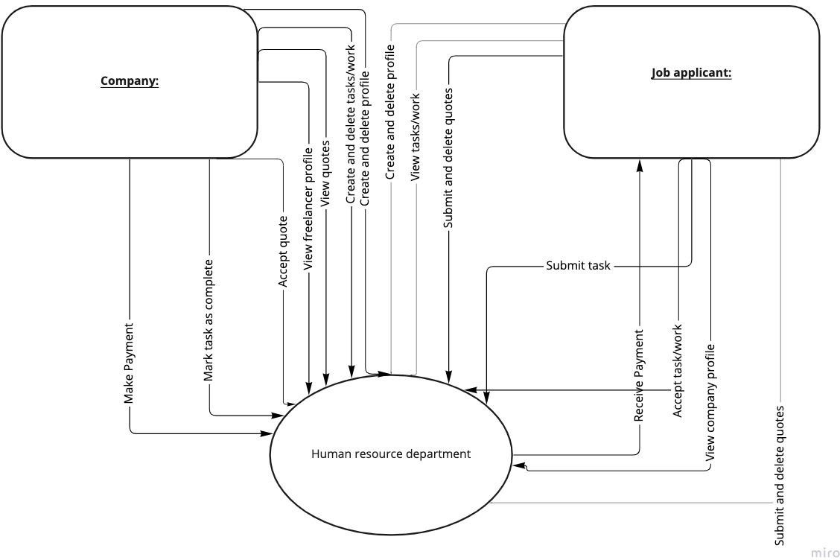

*Figure IX Context diagram*

#### Data flow diagram

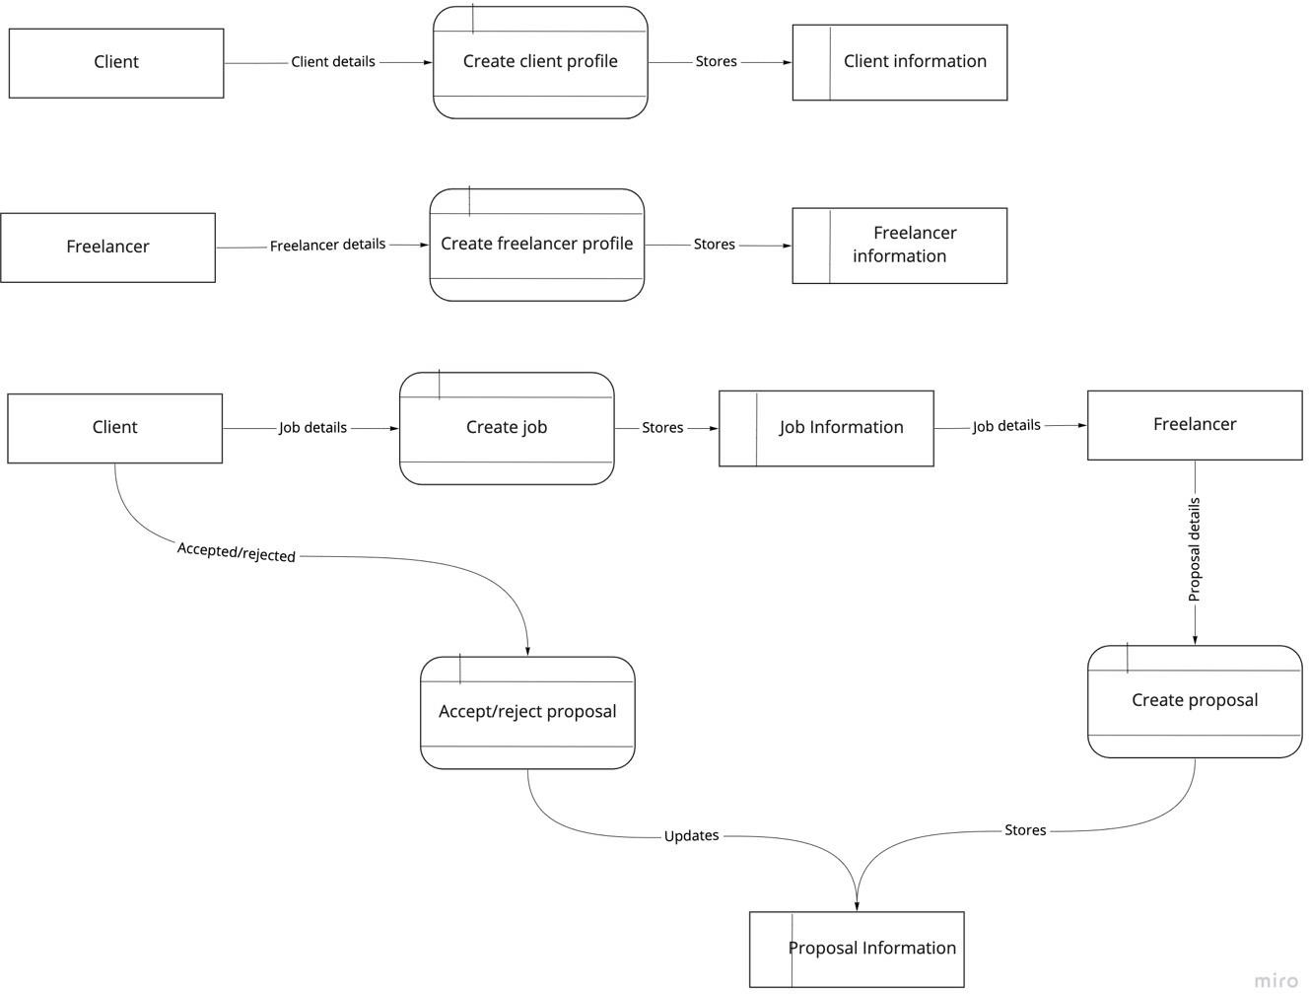

*Figure X Data flow diagram*

#### Flow charts

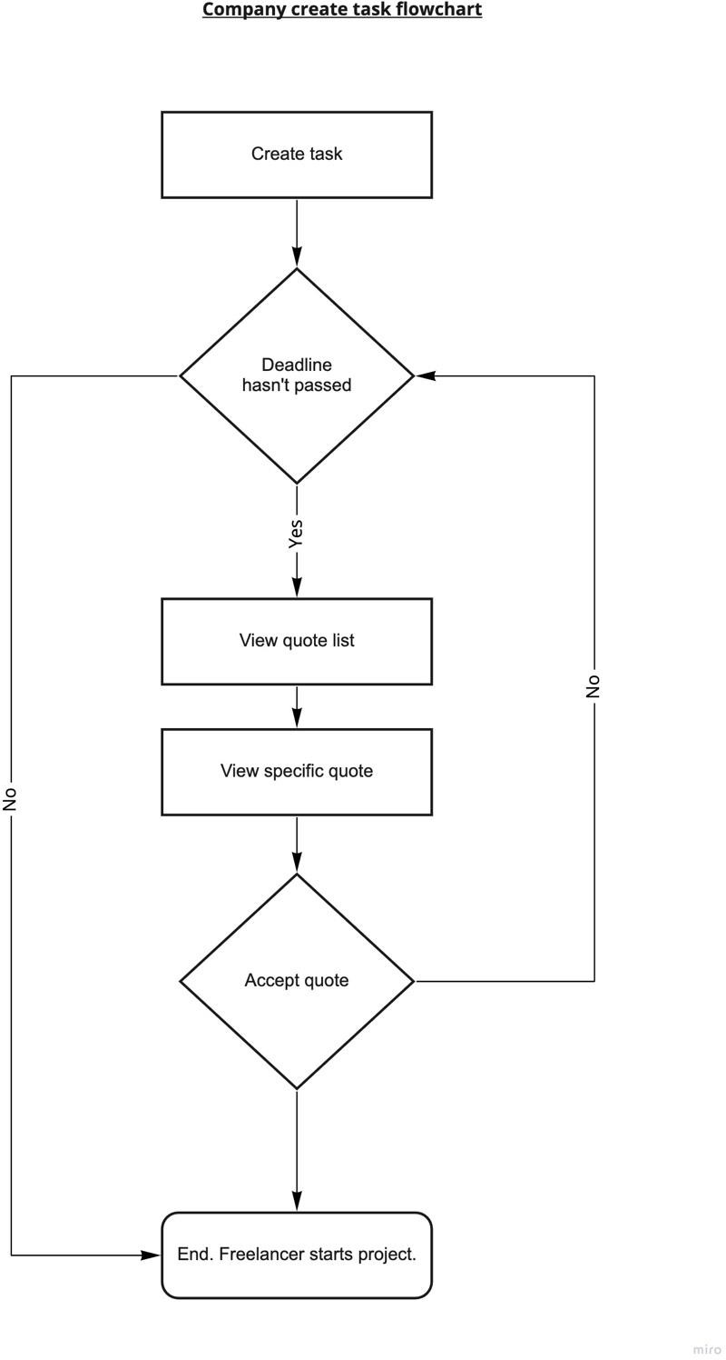

*Figure XI Company create task flowchart*

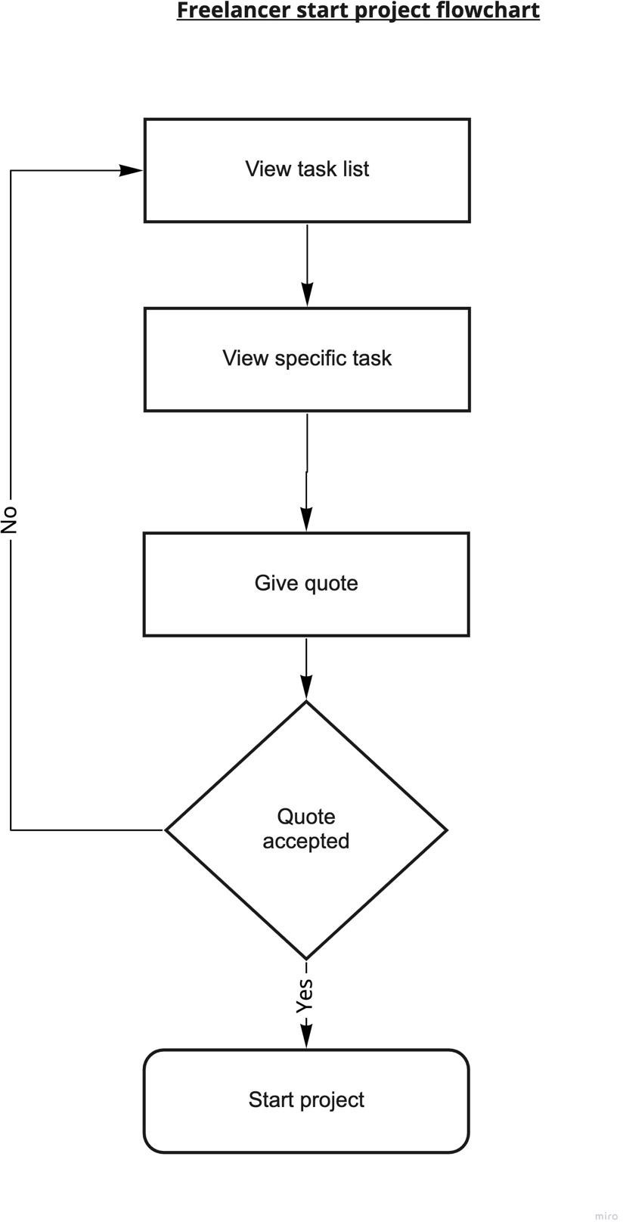

*Figure XII Freelancer start project flowchart*

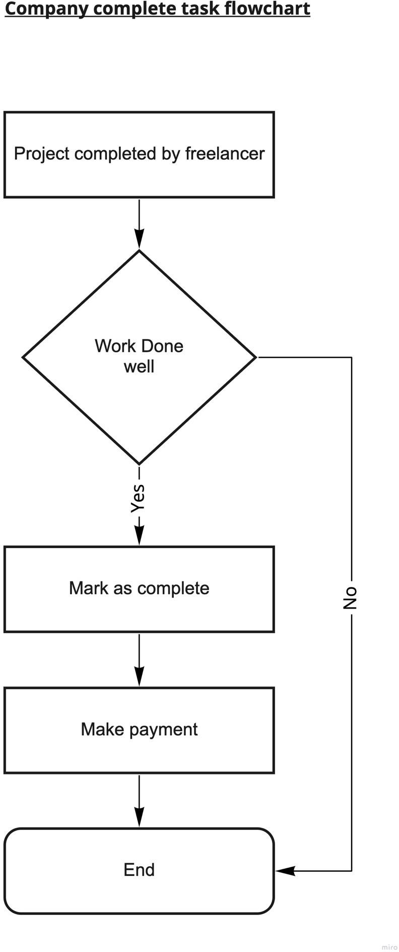

*Figure XIII Company complete task flowchart*

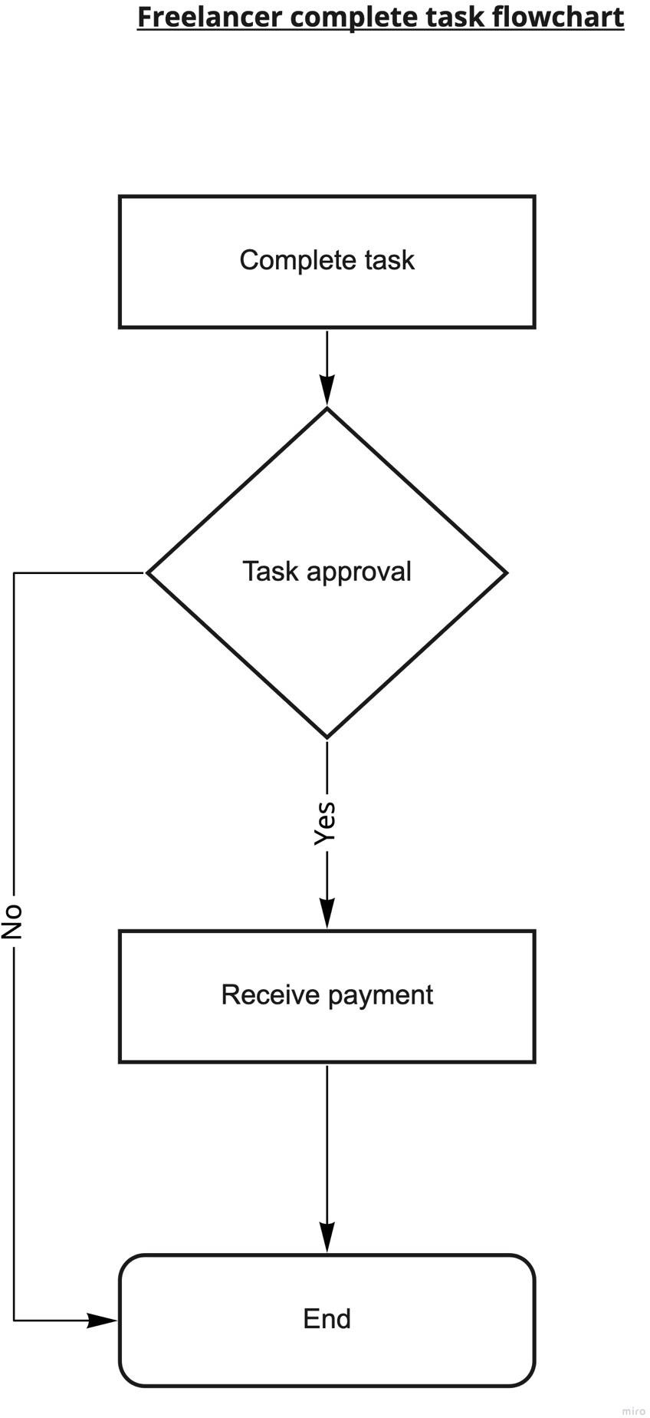

*Figure XIV Freelancer complete task flowchart*

### Chapter 4 summary

This chapter mainly focused on gaining a thorough understanding of the existing systems. This chapter also provides a detailed description of the users’ roles, responsibilities and relationships with each other. Diagrams like flowcharts and context diagrams have also been introduced to demonstrate the logic and relations of different processes within the system. The information gathered in this chapter is then used to inform and guide the next chapters (Design and Implementation).

## Chapter 5: System design of the proposed system

### Chapter 5 introduction

Systems design is the process of defining elements of a system like modules, architecture, components and their interfaces and data for a system based on the specified requirements. It is the process of defining, developing and designing systems which satisfies the specific needs and requirements of a business or organization. (The Economic Times, 2021)

Here, we take a deep dive into the system being built. An overview of how the system works, the different components of the system and the different roles played by each component will be examined. This chapter also looks at the strengths and weaknesses of the system together with the functional and non-functional requirements of the system among many others requirements.

### Description of the proposed system

This proposed system will provide a single integrated system where all the clients and freelancers will be able to interact efficiently in a single centralized system. Everything will be done online; from the posting of jobs, to the work being done and payments. The web application will be accessible via mobile phone or a computer through the use of an internet browser. The main goal of the system is to help solve the many deficiencies of the current manual systems.

The project will have three major user types; the freelancer, client and admin. They will all have their separate modules. Any user can sign up for the service by visiting the registration page. They will then have an email address and password they can use to login. Their profiles and passwords can be changed by visiting the edit profile and reset password pages respectively. Once logged in, a user can sign up as a freelancer of client and submit some documents to verify their identity. They will then be redirected to their respective dashboard. Admins, via the admin dashboard, have a bird’s eye view of the system. Seeing reports on jobs, job proposals, etc. An admin can also issue or revoke admin rights to another user via the admin panel. Admins also have access to user logs allowing them to see actions performed by users in the system.

Clients can at any time create jobs online selecting the jobs category which will be viewed by freelancers. They will then proceed to pay for the job via MPesa. They can then view proposals

which they can choose to accept or reject. Once a proposal is accepted the freelancer will begin working on the task. Once the freelancer finishes and uploads the work for task, the client can view the work done on their dashboard. The client can than choose to accept the work and the freelancer will receive the payment. The client can then rate the freelancer’s work. If anything went wrong, a refund will be issued to the client.

Once a freelancers log in to their dashboard, they can see available jobs. They can then choose to send proposals to jobs and hope that the client will accept them. If they have a change of heart, they can choose to withdraw the proposal. Once a proposal is accepted the freelancer (who created the proposal) will begin working on the task and uploads it via a zip file once done. The client has already paid for the job and payment is guaranteed to the freelancer if the job is done well. Once the freelancer finishes the work for task, the client than choose to accept the work and the freelancer will receive the payment via Mpesa. The freelancer can than rate the client. The freelancer can work on multiple jobs at once.

#### Strengths

Here are some of the strengths of the new system:

1. Better work-life balance and control over your schedule: work is very flexible.
2. Lack of a geographic limitation for work.
3. Such jobs will appeal to millennials. Today’s millennials do not want to be saddled with the boring grind of traditional 9-to-5 work. They want the freedom to work at their own pace and observe a good balance between their professional and personal lives.
4. A very high number of and range of applicants reached compared to previous methods that do not leverage the internet.
5. Shot recruiting cycles.
6. Payments are received immediately after completing work.

#### Weakness

Here are some of the weaknesses:

1. It will be difficult for freelancers to gain early consideration for a position that has not yet been advertised through personal referrals. (Thomas, 2019)
2. Workers not having fixed baseline salary that most companies can't decrease without cause.
3. Workers not part of a company’s upcoming expansion plans.
4. Fewer long-term contracts/work.
5. There is commission charged on the payment of the worker by a middleman (the owners of the freelancing site).

### Conceptual architecture of the proposed system

A conceptual architecture is a high-level design or an absotract which includes most important entities and components. The man goal of conceptual architecture is to build an architectural design which will provide an understandable picture of the general purpose of the proposed system. Components of conceptual architecture include external systems and major technology systems that are required for integration or overall functionality, system functionality and high- level data flow. (TechieDolphin, 2006)

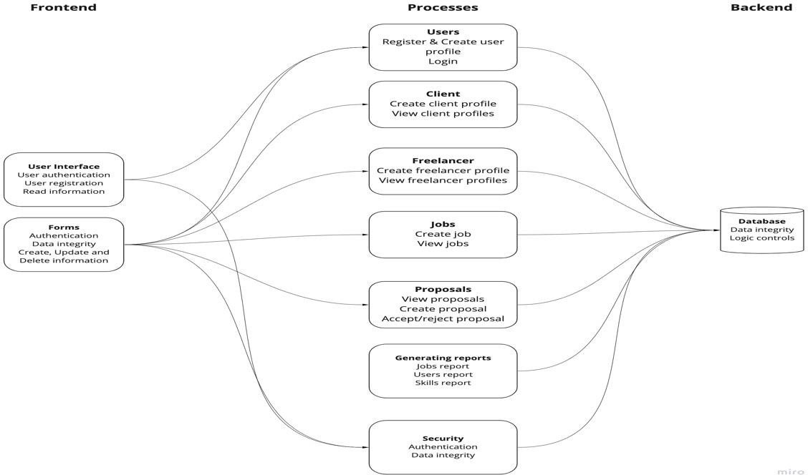

*Figure XV Conceptual architecture*

### Process logic design of the proposed system

The process logic design of a system tries to describe the various steps involved in designing the system. The steps involved include: coming up with use case diagrams and activity diagrams for the system, sequence and class diagrams for the system, flow charts, context diagrams and data flow diagrams for the system.

#### Use case diagram

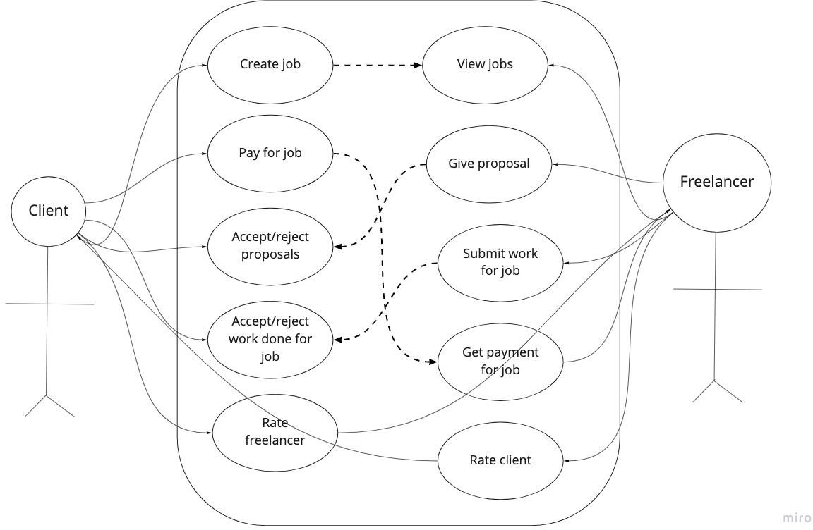

*Figure XVI Use case diagram*

#### Activity diagram

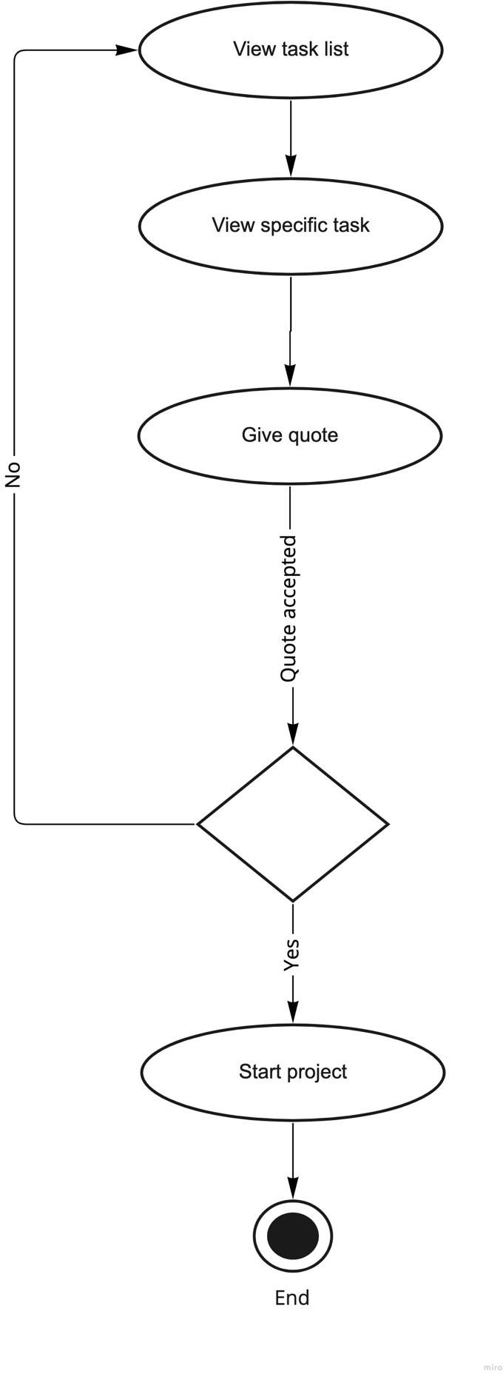

*Figure XVII Give proposal activity diagram*

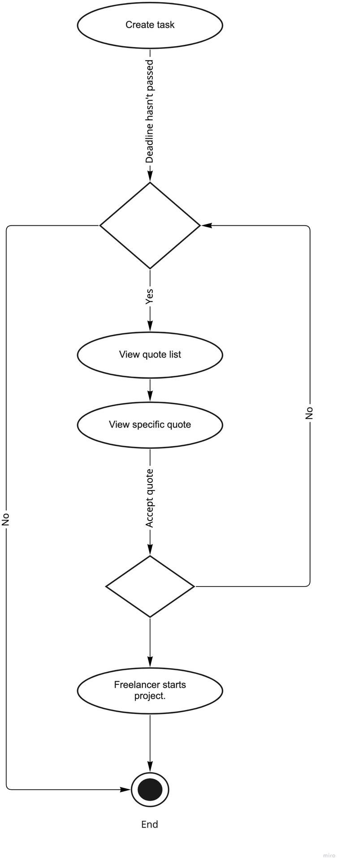

*Figure XVIII Create task activity diagram*

#### Sequence diagrams

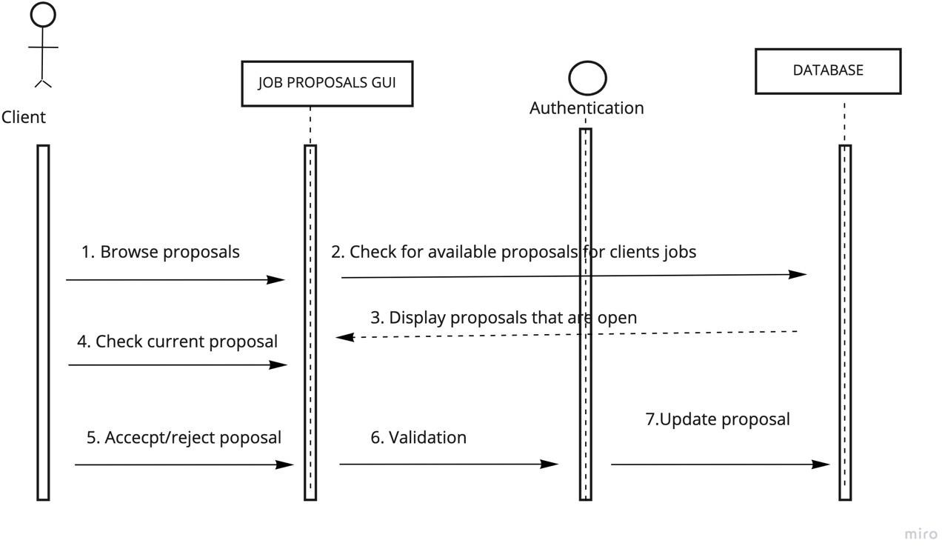

*Figure XIX Accept proposal sequence diagram*

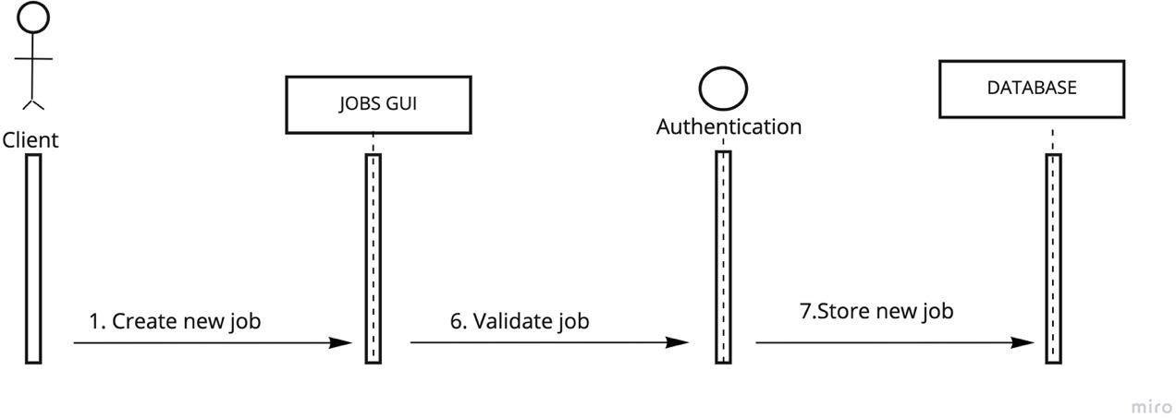

*Figure XX Create job sequence diagram*

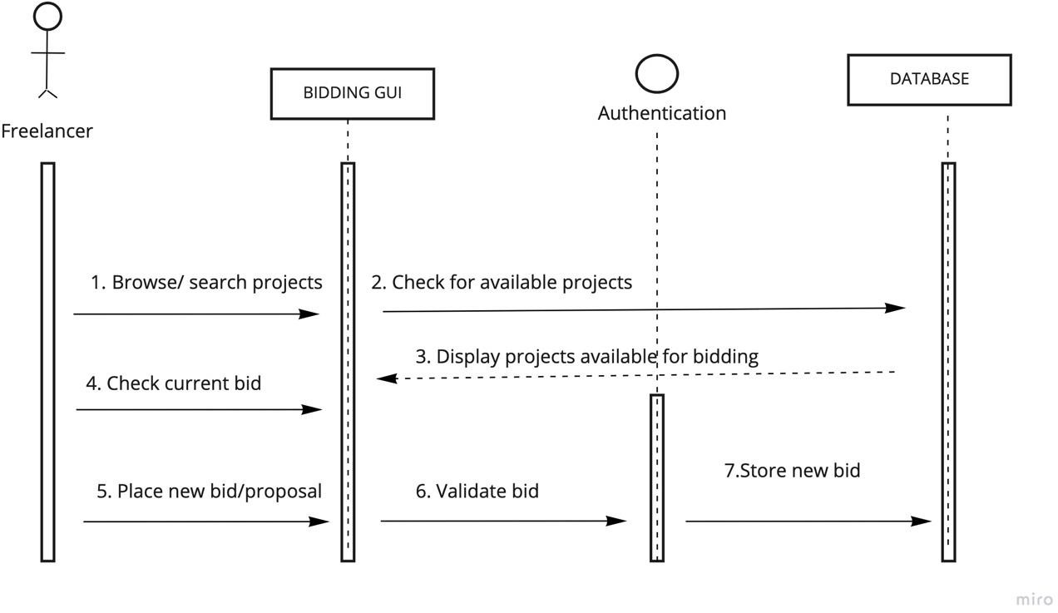

*Figure XXI Give proposal sequence diagram*

#### Class diagram

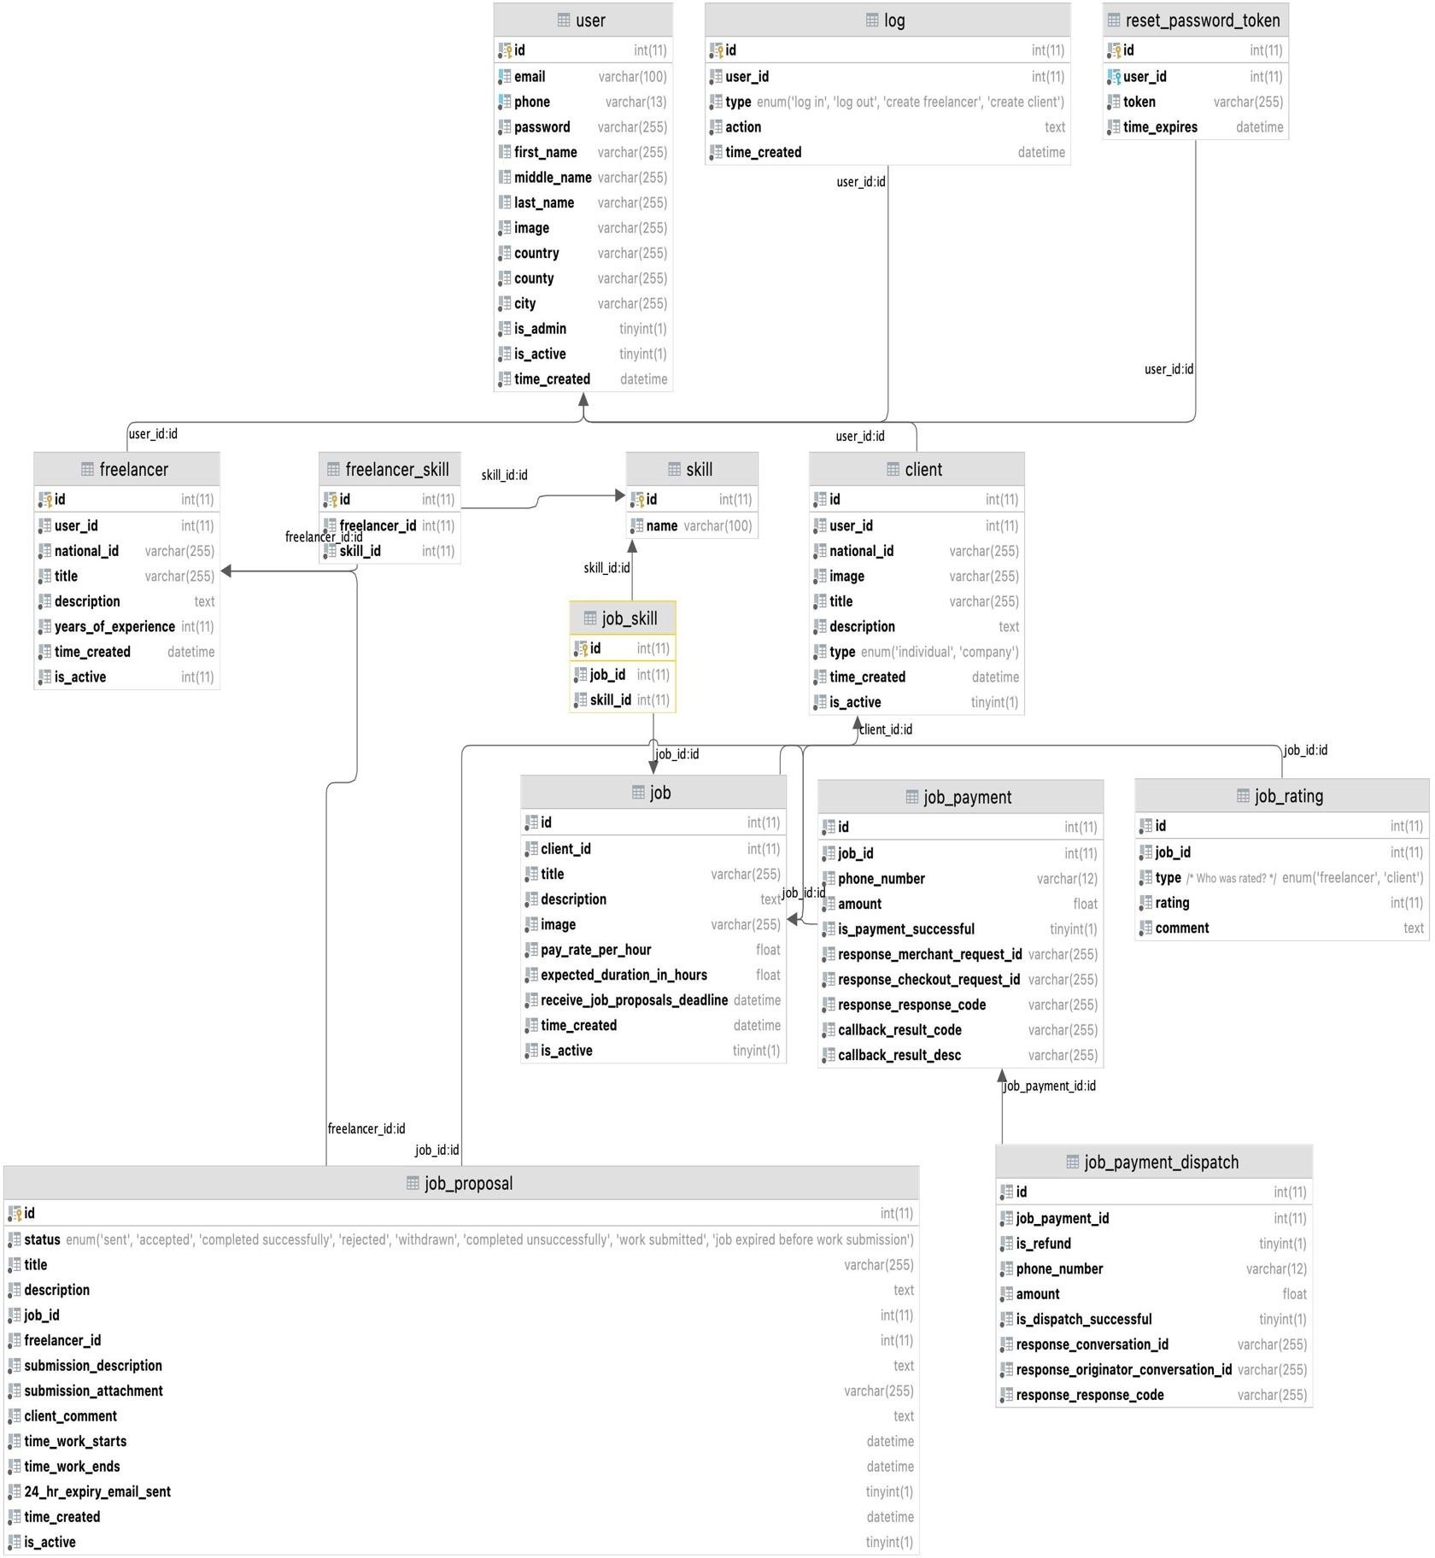

*Figure XXII Class Diagram*

#### Flow charts



*Figure XXIII Company create-task flowchart*



*Figure XXIV Freelancer start project flowchart*



*Figure XXV Company complete task flowchart*



*Figure XXVI Freelancer complete task flowchart*

#### Context diagrams

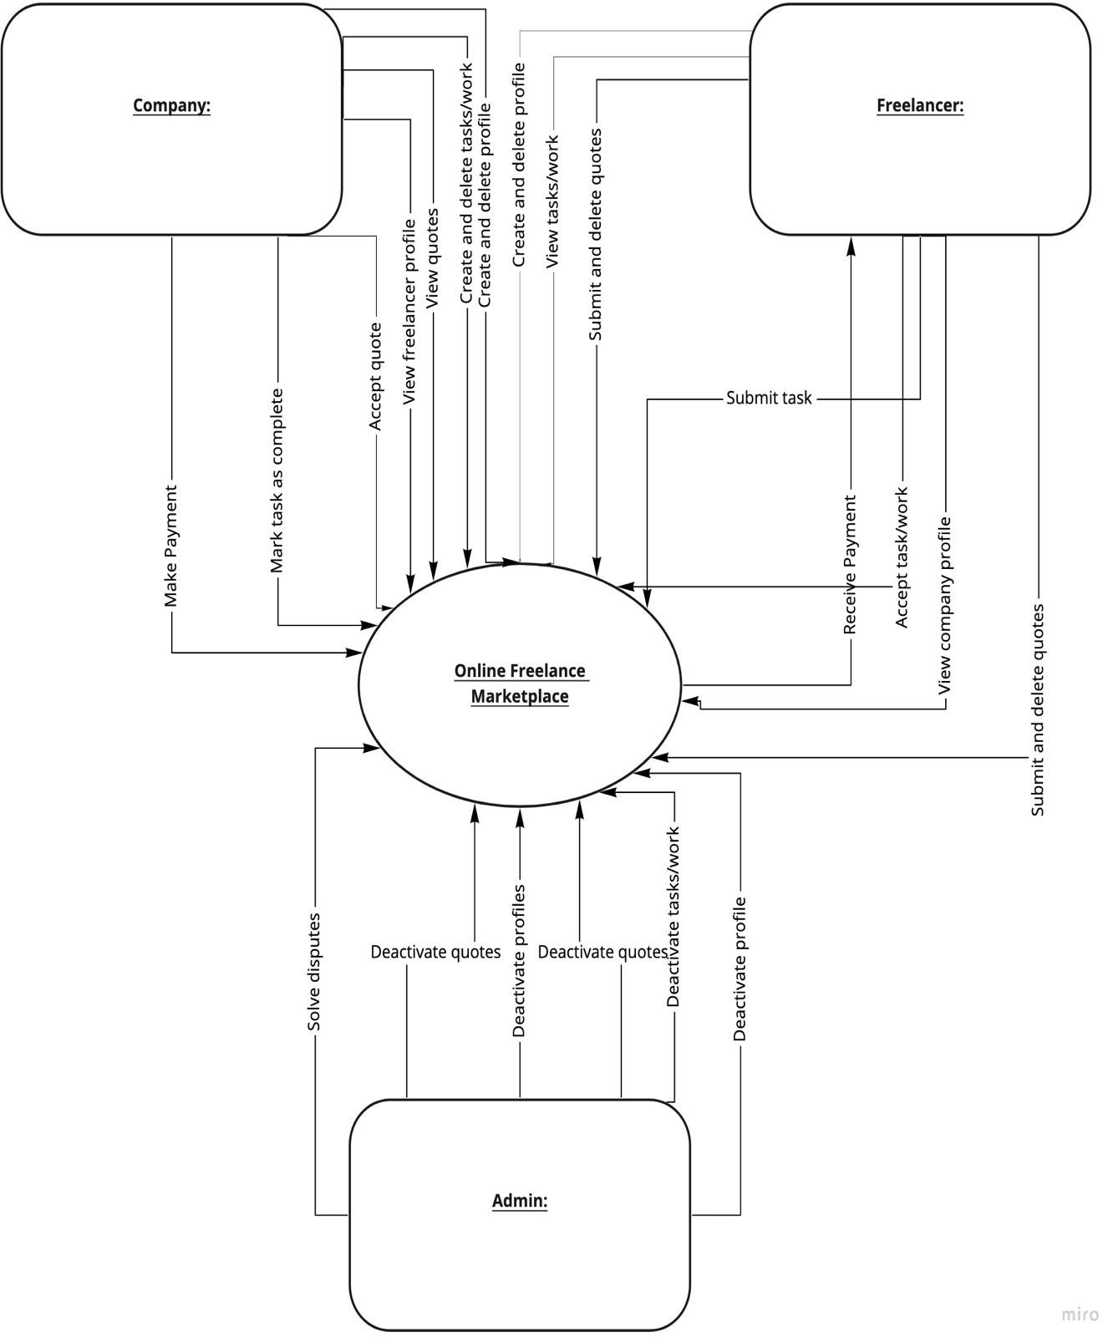

*Figure XXVII Context diagram*

### Database design:

#### Entity Relationship (ER) diagram

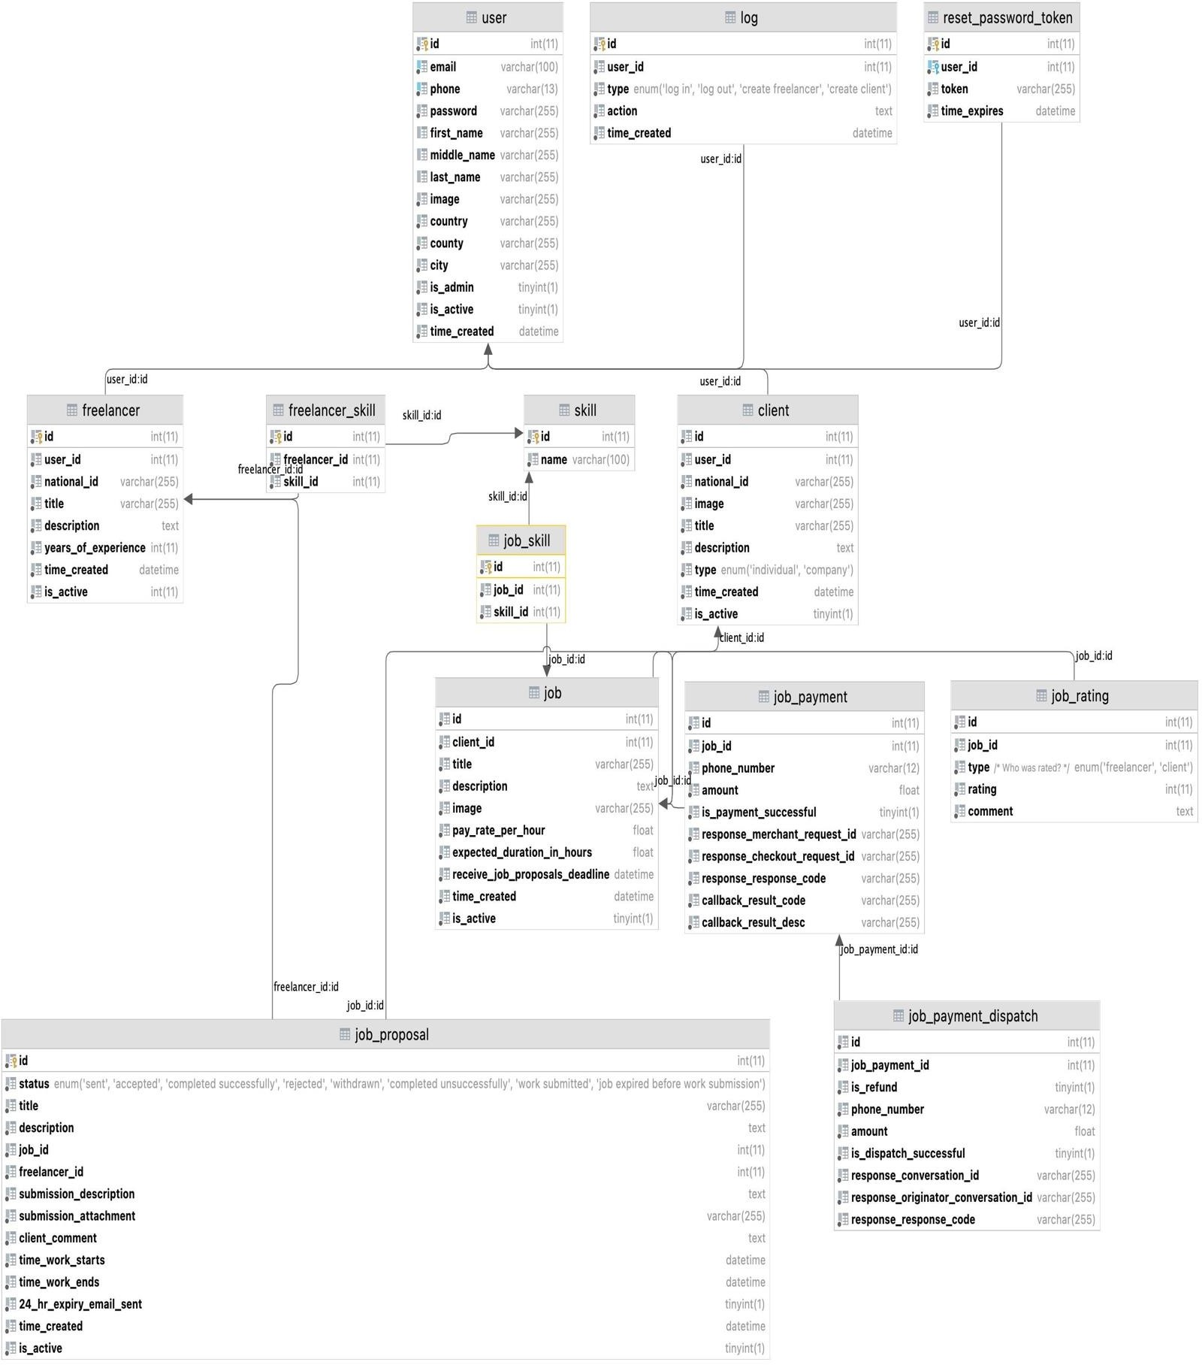

*Figure XXVIII ER diagram*

#### Normalization

* + - 1. First Normal Form (1NF)

For a table to be in the First Normal Form, it should follow the following 4 rules:

1. It should only have single(atomic) valued attributes/columns.
2. Values stored in a column should be of the same domain
3. All the columns in a table should have unique names.
4. And the order in which data is stored, does not matter. The above is in various tables like the user table:

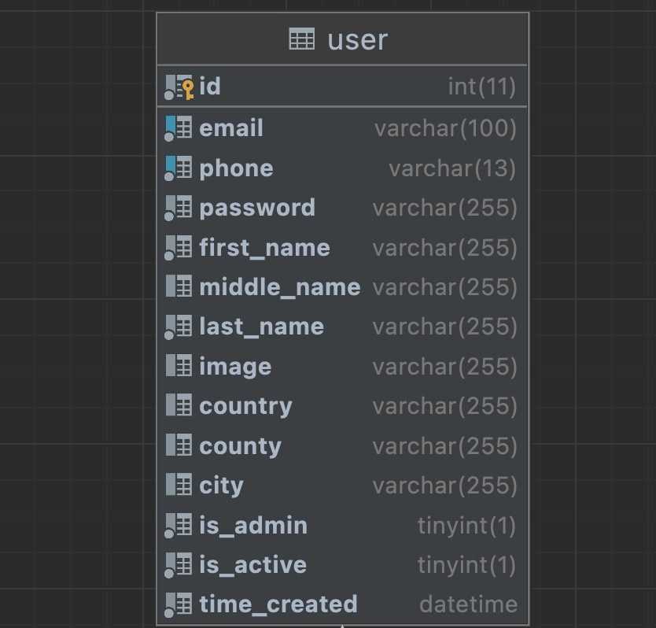

*Figure XXIX 1NF*

* + - 1. Second Normal Form (2NF)

For a table to be in the Second Normal Form:

1. It should be in the First Normal form.
2. And, it should not have Partial Dependency.

The above is in various tables like the user table’s relationship with client and freelancer:

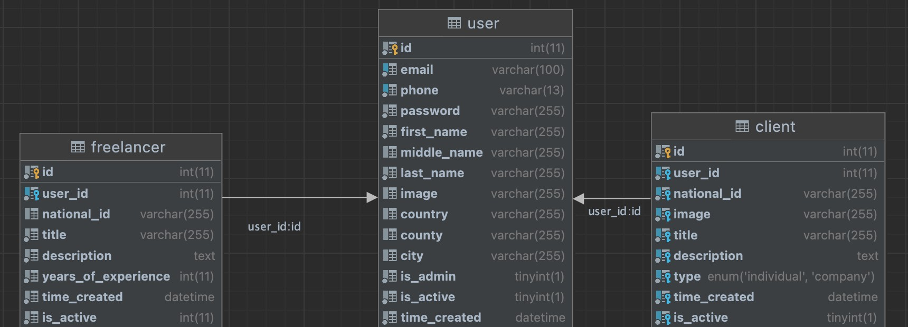

*Figure XXX 2NF*

* + - 1. Third Normal Form (3NF)

A table is said to be in the Third Normal Form when:

1. It is in the Second Normal form.
2. And, it doesn't have Transitive Dependency.

#### Data dictionary

Data dictionary is an inventory of data elements in a database or data model with detailed description of its format, relationships, meaning, source and usage. (dataedo, 2020)

See the system’s data dictionary below:

* + - 1. client

|  |  |  |  |  |  |  |
| --- | --- | --- | --- | --- | --- | --- |
| **Column** | **Type** | **Null** | **Default** | **Links to** | **Comments** | **Media type** |
| id *(Primary)* | int(11) | No |  |  |  |  |

|  |  |  |  |  |  |  |
| --- | --- | --- | --- | --- | --- | --- |
| user_id | int(11) | No |  | user -> id |  |  |
| national_id | varchar(255) | Yes | *NULL* |  |  |  |
| image | varchar(255) | Yes | *NULL* |  |  |  |
| title | varchar(255) | No |  |  |  |  |
| description | text | No |  |  |  |  |
| type | enum('individual', 'company') | No | company |  |  |  |
| time_created | datetime | No | current_timestamp() |  |  |  |
| is_active | tinyint(1) | No | 1 |  |  |  |

*Table III client*

* + - * 1. Indexes

|  |  |  |  |  |  |  |  |  |
| --- | --- | --- | --- | --- | --- | --- | --- | --- |
| **Keyname** | **Type** | **Unique** | **Packed** | **Column** | **Cardinality** | **Collation** | **Null** | **Comment** |
| PRIMARY | BTREE | Yes | No | id | 23 | A | No |  |
| user_id | BTREE | Yes | No | user_id | 23 | A | No |  |

*Table IV client index*

* + - 1. freelancer

|  |  |  |  |  |  |  |
| --- | --- | --- | --- | --- | --- | --- |
| **Column** | **Type** | **Null** | **Default** | **Links to** | **Comments** | **Media type** |
| id *(Primary)* | int(11) | No |  |  |  |  |
| user_id | int(11) | No |  | user -> id |  |  |
| national_id | varchar(255) | Yes | *NULL* |  |  |  |
| title | varchar(255) | No |  |  |  |  |
| description | text | No |  |  |  |  |
| years_of_experience | int(11) | No |  |  |  |  |

|  |  |  |  |  |  |  |
| --- | --- | --- | --- | --- | --- | --- |
| time_created | datetime | No | current_timestamp() |  |  |  |
| is_active | int(11) | No | 1 |  |  |  |

*Table V freelancer*

* + - * 1. Indexes

|  |  |  |  |  |  |  |  |  |
| --- | --- | --- | --- | --- | --- | --- | --- | --- |
| **Keyname** | **Type** | **Unique** | **Packed** | **Column** | **Cardinality** | **Collation** | **Null** | **Comment** |
| PRIMARY | BTREE | Yes | No | id | 2 | A | No |  |
| user_id_2 | BTREE | Yes | No | user_id | 2 | A | No |  |
| user_id | BTREE | No | No | user_id | 2 | A | No |  |

*Table VI freelancer index*

* + - 1. freelancer_skill

|  |  |  |  |  |  |  |
| --- | --- | --- | --- | --- | --- | --- |
| **Column** | **Type** | **Null** | **Default** | **Links to** | **Comments** | **Media type** |
| id *(Primary)* | int(11) | No |  |  |  |  |
| freelancer_id | int(11) | No |  | freelancer -> id |  |  |
| skill_id | int(11) | No |  | skill -> id |  |  |

*Table VII freelancer_skill*

* + - * 1. Indexes

|  |  |  |  |  |  |  |  |  |
| --- | --- | --- | --- | --- | --- | --- | --- | --- |
| **Keyname** | **Type** | **Uniqu e** | **Packe d** | **Column** | **Cardinalit y** | **Collatio n** | **Nul l** | **Commen t** |
| PRIMARY | BTRE E | Yes | No | id | 10 | A | No |  |
| freelancer_i d | BTRE E | Yes | No | freelancer_i d | 10 | A | No |  |
| skill_id | 10 | A | No |
| skill_id | BTRE E | No | No | skill_id | 10 | A | No |  |

*Table VIII freelancer_skill index*

* + - 1. job

|  |  |  |  |  |  |  |
| --- | --- | --- | --- | --- | --- | --- |
| **Column** | **Type** | **Nul l** | **Default** | **Link s to** | **Comment s** | **Medi a type** |
| id *(Primary)* | int(11) | No |  |  |  |  |
| client_id | int(11) | No |  | client  -> id |  |  |
| title | varchar(25 5) | No |  |  |  |  |
| description | text | No |  |  |  |  |
| image | varchar(25 5) | Yes | *NULL* |  |  |  |
| pay_rate_per_hour | float | No |  |  |  |  |
| expected_duration_in_hours | float | No |  |  |  |  |
| receive_job_proposals_deadl ine | datetime | No |  |  |  |  |
| time_created | datetime | No | current_timestam p() |  |  |  |
| is_active | tinyint(1) | No | 1 |  |  |  |

*Table IX job*

* + - * 1. Indexes

|  |  |  |  |  |  |  |  |  |
| --- | --- | --- | --- | --- | --- | --- | --- | --- |
| **Keyname** | **Type** | **Unique** | **Packed** | **Column** | **Cardinality** | **Collation** | **Null** | **Comment** |
| PRIMARY | BTREE | Yes | No | id | 34 | A | No |  |
| client_id | BTREE | No | No | client_id | 34 | A | No |  |

*Table X job index*

* + - 1. job_payment

|  |  |  |  |  |  |  |
| --- | --- | --- | --- | --- | --- | --- |
| **Column** | **Type** | **Null** | **Default** | **Links to** | **Comments** | **Media type** |
| id *(Primary)* | int(11) | No |  |  |  |  |
| job_id | int(11) | No |  | job -> id |  |  |
| phone_number | varchar(12) | No |  |  |  |  |
| amount | float | No |  |  |  |  |
| is_payment_successful | tinyint(1) | No | 0 |  |  |  |
| response_merchant_request_id | varchar(255) | No |  |  |  |  |
| response_checkout_request_id | varchar(255) | No |  |  |  |  |
| response_response_code | varchar(255) | Yes | *NULL* |  |  |  |
| callback_result_code | varchar(255) | Yes | *NULL* |  |  |  |
| callback_result_desc | varchar(255) | Yes | *NULL* |  |  |  |

*Table XI job payment*

* + - * 1. Indexes

|  |  |  |  |  |  |  |  |  |
| --- | --- | --- | --- | --- | --- | --- | --- | --- |
| **Keyname** | **Type** | **Unique** | **Packed** | **Column** | **Cardinality** | **Collation** | **Null** | **Comment** |
| PRIMARY | BTREE | Yes | No | id | 34 | A | No |  |
| job_id | BTREE | No | No | job_id | 34 | A | No |  |

*Table XII job payment index*

* + - 1. job_payment_dispatch

|  |  |  |  |  |  |  |
| --- | --- | --- | --- | --- | --- | --- |
| **Column** | **Type** | **Nul l** | **Defaul t** | **Links to** | **Comment s** | **Medi a type** |
| id *(Primary)* | int(11) | No |  |  |  |  |

|  |  |  |  |  |  |  |
| --- | --- | --- | --- | --- | --- | --- |
| job_payment_id | int(11) | No |  | job_payme nt -> id |  |  |
| is_refund | tinyint(1) | No | 0 |  |  |  |
| phone_number | varchar(12) | No |  |  |  |  |
| amount | float | No |  |  |  |  |
| is_dispatch_successful | tinyint(1) | No | 0 |  |  |  |
| response_conversation_id | varchar(25 5) | No |  |  |  |  |
| response_originator_conversation  _id | varchar(25 5) | No |  |  |  |  |
| response_response_code | varchar(25 5) | Yes | *NULL* |  |  |  |

*Table XIII job payment dispatch*

* + - * 1. Indexes

|  |  |  |  |  |  |  |  |  |
| --- | --- | --- | --- | --- | --- | --- | --- | --- |
| **Keyname** | **Type** | **Uniqu e** | **Packe d** | **Column** | **Cardinalit y** | **Collatio n** | **Nul l** | **Commen t** |
| PRIMAR Y | BTRE E | Yes | No | id | 2 | A | No |  |
| job_id | BTRE E | No | No | job_payment_i d | 2 | A | No |  |

*Table XIV job payment dispatch index*

* + - 1. job_proposal

|  |  |  |  |  |  |  |
| --- | --- | --- | --- | --- | --- | --- |
| **Column** | **Type** | **Nul l** | **Default** | **Links to** | **Comment s** | **Medi a type** |
| id *(Primary)* | int(11) | No |  |  |  |  |

|  |  |  |  |  |  |  |
| --- | --- | --- | --- | --- | --- | --- |
| status | enum('sent', 'accepted', 'completed successfully', 'rejected', 'withdrawn', 'completed unsuccessfull y', 'work submitted', 'job expired before work submission') | No | sent |  |  |  |
| title | varchar(255) | No |  |  |  |  |
| description | text | No |  |  |  |  |
| job_id | int(11) | No |  | job -> id |  |  |
| freelancer_id | int(11) | No |  | freelanc er -> id |  |  |
| submission_descriptio n | text | Yes | *NULL* |  |  |  |
| submission_attachmen t | varchar(255) | Yes | *NULL* |  |  |  |
| client_comment | text | Yes | *NULL* |  |  |  |
| time_work_starts | datetime | Yes | *NULL* |  |  |  |
| time_work_ends | datetime | Yes | *NULL* |  |  |  |
| 24_hr_expiry_email_s ent | tinyint(1) | No | 0 |  |  |  |
| time_created | datetime | No | current_timestam p() |  |  |  |

|  |  |  |  |  |  |  |
| --- | --- | --- | --- | --- | --- | --- |
| is_active | tinyint(1) | No | 1 |  |  |  |

*Table XV job propossal*

* + - * 1. Indexes

|  |  |  |  |  |  |  |  |  |
| --- | --- | --- | --- | --- | --- | --- | --- | --- |
| **Keyname** | **Type** | **Uniqu e** | **Packe d** | **Column** | **Cardinalit y** | **Collatio n** | **Nul l** | **Commen t** |
| PRIMARY | BTRE E | Yes | No | id | 13 | A | No |  |
| job_id | BTRE E | Yes | No | job_id | 13 | A | No |  |
| freelancer_i d | 13 | A | No |
| freelancer_i d | BTRE E | No | No | freelancer_i d | 4 | A | No |  |

*Table XVI job proposal index*

* + - 1. job_rating

|  |  |  |  |  |  |  |
| --- | --- | --- | --- | --- | --- | --- |
| **Column** | **Type** | **Null** | **Default** | **Links to** | **Comments** | **Media type** |
| id *(Primary)* | int(11) | No |  |  |  |  |
| job_id | int(11) | No |  | job -> id |  |  |
| type | enum('freelancer', 'client') | No |  |  | Who was rated? |  |
| rating | int(11) | No |  |  |  |  |
| comment | text | Yes | *NULL* |  |  |  |

*Table XVII job rating*

* + - * 1. Indexes

|  |  |  |  |  |  |  |  |  |
| --- | --- | --- | --- | --- | --- | --- | --- | --- |
| **Keyname** | **Type** | **Unique** | **Packed** | **Column** | **Cardinality** | **Collation** | **Null** | **Comment** |
| PRIMARY | BTREE | Yes | No | id | 7 | A | No |  |

|  |  |  |  |  |  |  |  |  |
| --- | --- | --- | --- | --- | --- | --- | --- | --- |
| **Keyname** | **Type** | **Unique** | **Packed** | **Column** | **Cardinality** | **Collation** | **Null** | **Comment** |
| job_id | BTREE | Yes | No | job_id | 7 | A | No |  |
| type | 7 | A | No |

*Table XVIII job rating index*

* + - 1. job_skill

|  |  |  |  |  |  |  |
| --- | --- | --- | --- | --- | --- | --- |
| **Column** | **Type** | **Null** | **Default** | **Links to** | **Comments** | **Media type** |
| id *(Primary)* | int(11) | No |  |  |  |  |
| job_id | int(11) | No |  | job -> id |  |  |
| skill_id | int(11) | No |  | skill -> id |  |  |

*Table XIX job skill*

* + - * 1. Indexes

|  |  |  |  |  |  |  |  |  |
| --- | --- | --- | --- | --- | --- | --- | --- | --- |
| **Keyname** | **Type** | **Unique** | **Packed** | **Column** | **Cardinality** | **Collation** | **Null** | **Comment** |
| PRIMARY | BTREE | Yes | No | id | 69 | A | No |  |
| job_id | BTREE | Yes | No | job_id | 69 | A | No |  |
| skill_id | 69 | A | No |
| skill_id | BTREE | No | No | skill_id | 69 | A | No |  |

*Table XX job skill index*

* + - 1. log

|  |  |  |  |  |  |  |
| --- | --- | --- | --- | --- | --- | --- |
| **Column** | **Type** | **Null** | **Default** | **Links to** | **Comments** | **Media type** |
| id *(Primary)* | int(11) | No |  |  |  |  |
| user_id | int(11) | Yes | *NULL* | user -> id |  |  |
| type | enum('Log In', 'Log Out', 'Create | Yes | *NULL* |  |  |  |

|  |  |  |  |  |  |  |
| --- | --- | --- | --- | --- | --- | --- |
|  | Freelancer', 'Create Client') |  |  |  |  |  |
| action | text | No |  |  |  |  |
| time_created | datetime | No | current_timestamp() |  |  |  |

*Table XXI log*

* + - * 1. Indexes

|  |  |  |  |  |  |  |  |  |
| --- | --- | --- | --- | --- | --- | --- | --- | --- |
| **Keyname** | **Type** | **Unique** | **Packed** | **Column** | **Cardinality** | **Collation** | **Null** | **Comment** |
| PRIMARY | BTREE | Yes | No | id | 16 | A | No |  |
| user_id | BTREE | No | No | user_id | 8 | A | Yes |  |

*Table XXII log index*

* + - 1. reset_password_token

|  |  |  |  |  |  |  |
| --- | --- | --- | --- | --- | --- | --- |
| **Column** | **Type** | **Null** | **Default** | **Links to** | **Comments** | **Media type** |
| id *(Primary)* | int(11) | No |  |  |  |  |
| user_id | int(11) | No |  | user -> id |  |  |
| token | varchar(255) | No |  |  |  |  |
| time_expires | datetime | No |  |  |  |  |

*Table XXIII reset password token*

* + - * 1. Indexes

|  |  |  |  |  |  |  |  |  |
| --- | --- | --- | --- | --- | --- | --- | --- | --- |
| **Keyname** | **Type** | **Unique** | **Packed** | **Column** | **Cardinality** | **Collation** | **Null** | **Comment** |
| PRIMARY | BTREE | Yes | No | id | 0 | A | No |  |
| user_id | BTREE | No | No | user_id | 0 | A | No |  |

*Table XXIV reset password token index*

* + - 1. skill

|  |  |  |  |  |  |  |
| --- | --- | --- | --- | --- | --- | --- |
| **Column** | **Type** | **Null** | **Default** | **Links to** | **Comments** | **Media type** |
| id *(Primary)* | int(11) | No |  |  |  |  |

|  |  |  |  |  |  |  |
| --- | --- | --- | --- | --- | --- | --- |
| name | varchar(100) | No |  |  |  |  |

*Table XXV skill*

* + - * 1. Indexes

|  |  |  |  |  |  |  |  |  |
| --- | --- | --- | --- | --- | --- | --- | --- | --- |
| **Keyname** | **Type** | **Unique** | **Packed** | **Column** | **Cardinality** | **Collation** | **Null** | **Comment** |
| PRIMARY | BTREE | Yes | No | id | 23 | A | No |  |
| name | BTREE | Yes | No | name | 23 | A | No |  |

*Table XXVI skill index*

* + - 1. user

|  |  |  |  |  |  |  |
| --- | --- | --- | --- | --- | --- | --- |
| **Column** | **Type** | **Null** | **Default** | **Links to** | **Comments** | **Media type** |
| id *(Primary)* | int(11) | No |  |  |  |  |
| email | varchar(100) | No |  |  |  |  |
| phone | varchar(13) | No |  |  |  |  |
| password | varchar(255) | No |  |  |  |  |
| first_name | varchar(255) | No |  |  |  |  |
| middle_name | varchar(255) | Yes | *NULL* |  |  |  |
| last_name | varchar(255) | No |  |  |  |  |
| image | varchar(255) | Yes | *NULL* |  |  |  |
| country | varchar(255) | Yes | Kenya |  |  |  |
| county | varchar(255) | Yes | *NULL* |  |  |  |
| city | varchar(255) | Yes | *NULL* |  |  |  |
| is_admin | tinyint(1) | No | 0 |  |  |  |
| is_active | tinyint(1) | No | 1 |  |  |  |
| time_created | datetime | No | current_timestamp() |  |  |  |

*Table XXVII user*

* + - * 1. Indexes

|  |  |  |  |  |  |  |  |  |
| --- | --- | --- | --- | --- | --- | --- | --- | --- |
| **Keyname** | **Type** | **Unique** | **Packed** | **Column** | **Cardinality** | **Collation** | **Null** | **Comment** |
| PRIMARY | BTREE | Yes | No | id | 69 | A | No |  |
| email | BTREE | Yes | No | email | 69 | A | No |  |
| phone | BTREE | Yes | No | phone | 69 | A | No |  |

*Table XXVIII user index*

### I/O of the proposed system

#### Freelancer dashboard mock up

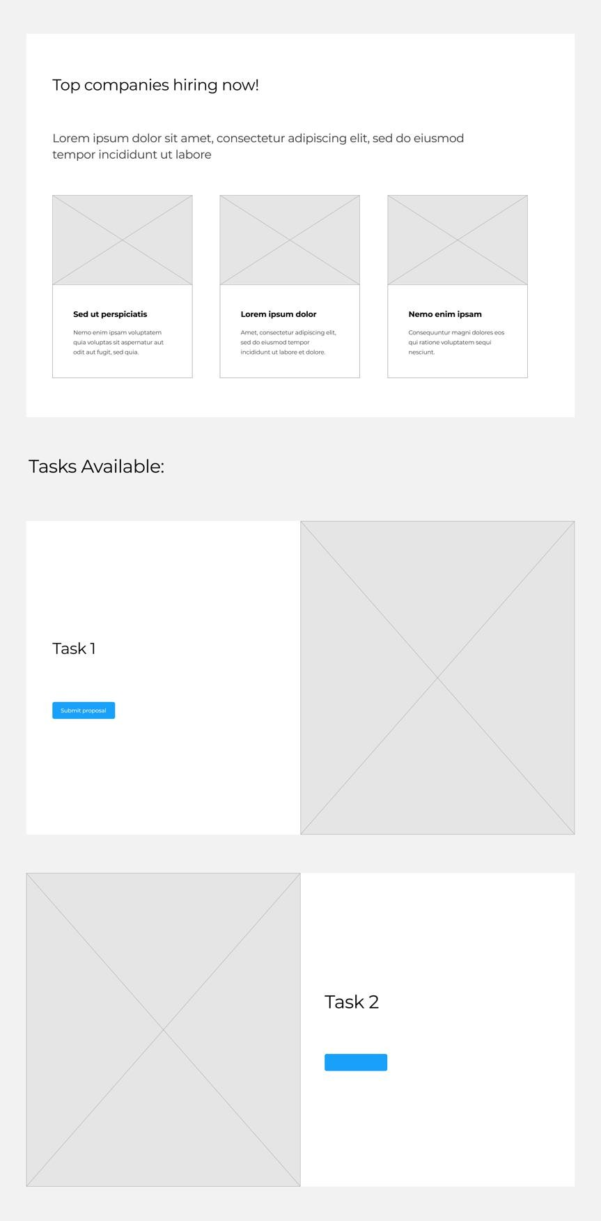

*Figure XXXI Freelancer dashboard mock up*

#### Company dashboard mock up

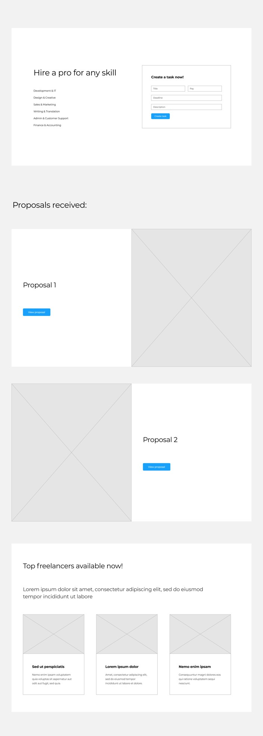

*Figure XXXII Company dashboard mock up*

#### Home page mockup

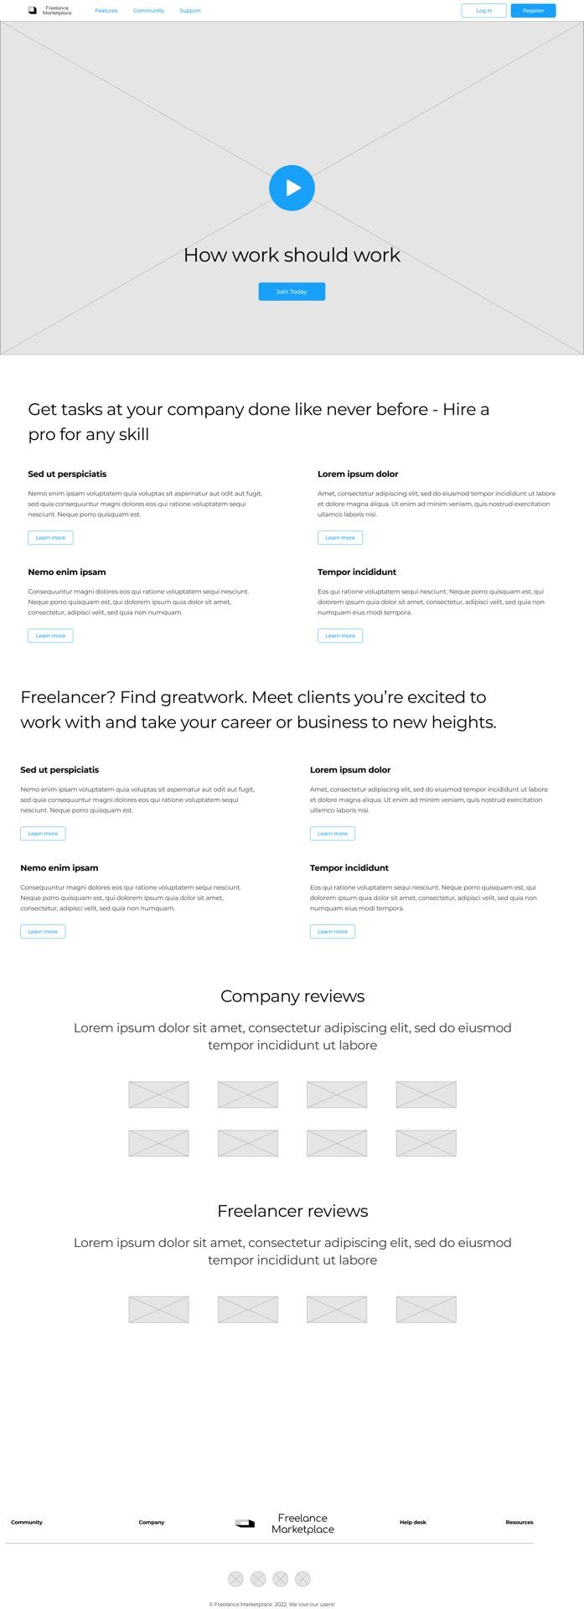

*Figure XXXIII Home page mock up*

### Chapter 5 summary

This chapter mainly focused on gaining a thorough understanding of the new system in a mostly technical way. This chapter also provides a detailed description of the users’ roles, responsibilities and relationships with each other. Diagrams like flowcharts and context diagrams have also been introduced to demonstrate the logic and relations of different processes within the system.

## Chapter 6: Implementation system & testing

### Chapter 6 introduction

This chapter covers all the testing and implementation processes.

The main purpose of this implementation phase is to deliver the specifications of the system from the design stage into a reliable system with clarity, flow and little or no errors at all. Another important purpose of this phase is to have the documentation for the system and to provide support for the system and upgrades for the sake of current users and future users.

System design was done step by step so as to ensure each module works well in that, each component integrates with each other seamlessly.

### System screenshots

#### Create job screenshot

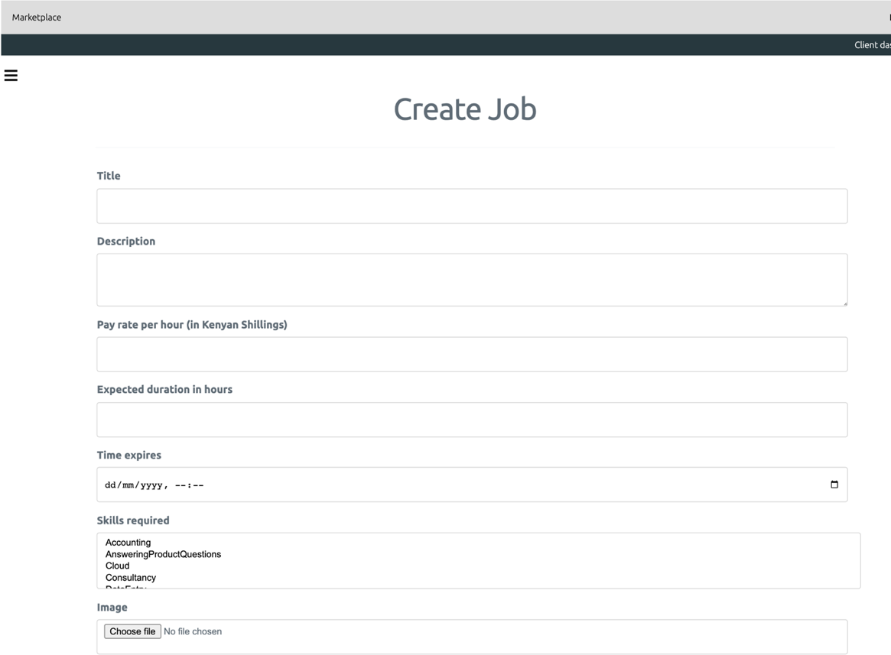This screen is only available to clients. From here, they can create jobs and assign its skills required and time it expires.

*Figure XXXIV Create jobs screenshot*

#### Jobs list screenshot

This screen is only available to freelancers. They can see active jobs from here. They can then click on a job to view more details.

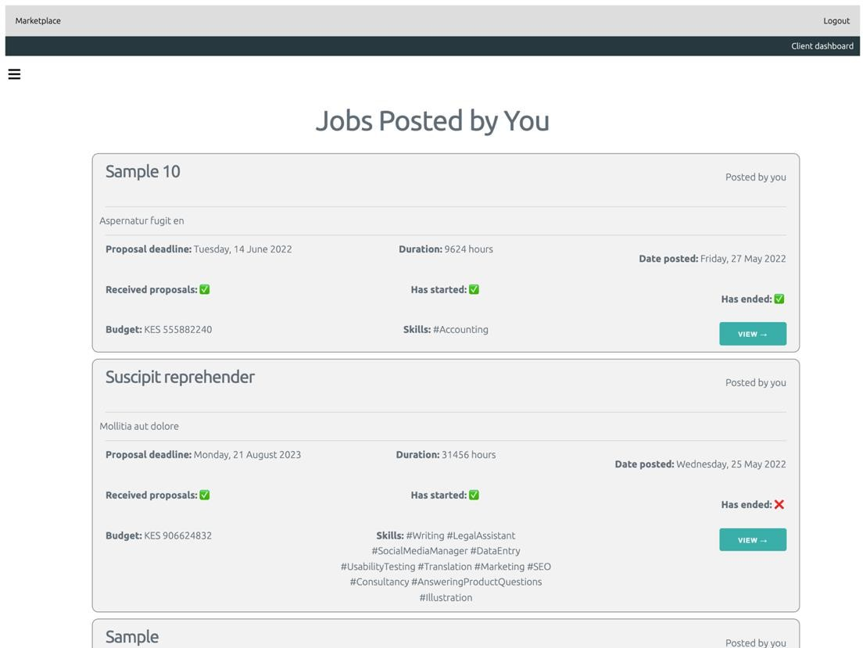

*Figure XXXV Jobs list screenshot*

#### View job screenshot

This screen is only available to both client and freelancers. They can see more details about a job.

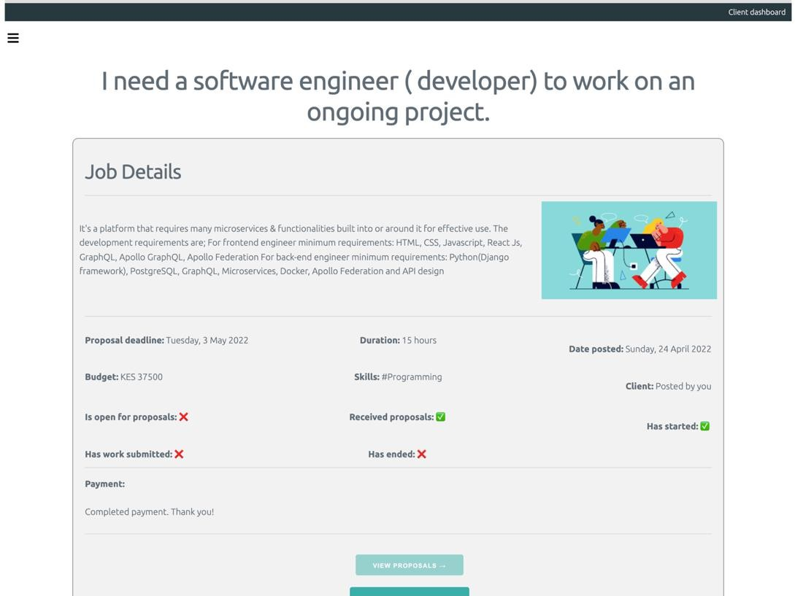

*Figure XXXVI View job screenshot*

#### Admin jobs list report screenshot

This screen is only available to admins. This is one of many reports that will be available for the admins to see and understand what is going on in the system.

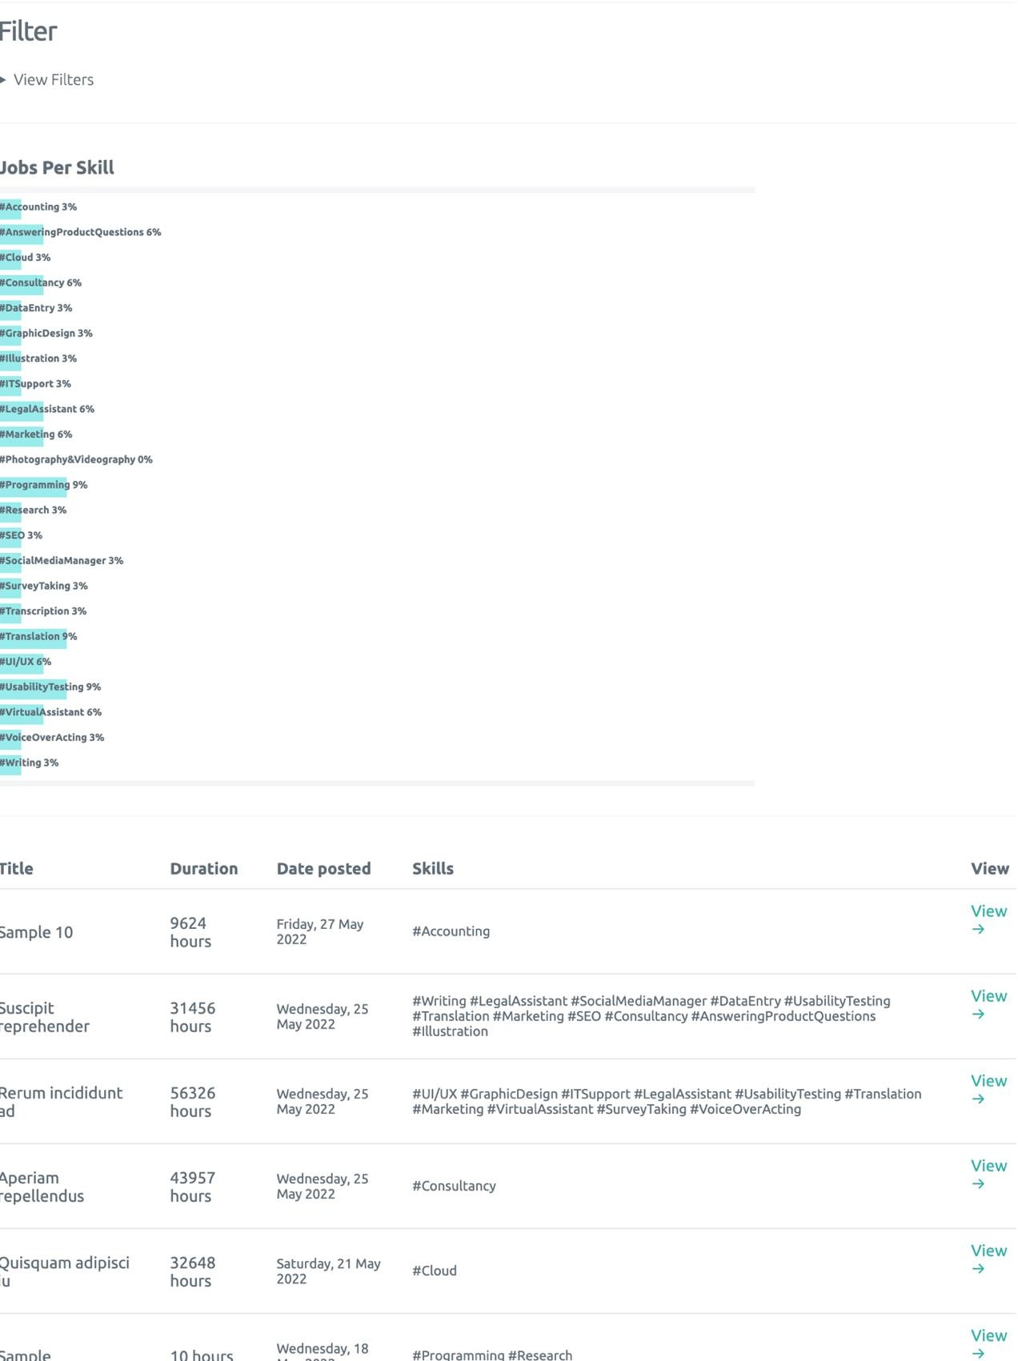

*Figure XXXVII Jobs report (In the Admin) screenshot*

### Testing plan

The scope, approach, resources, and timing of all testing activities are all prescribed in the Test Plan. The plan will specify the objects and features tested, and the testing methods used, the persons in charge of testing, the resources, and the schedule to be followed to complete the testing.

The test plan's goal is to ensure that the code is valid and that all functional and design requirements are met as defined in the documentation, to establish a testing technique and to determine which testing procedures should be used.

The system was tested once implementation was done. The developer was not the only one who tested the system. There wa a selection of thirty volunteers who had never interacted with the system before; fifteen testing it as freelancers and fifteen testing it as clients. They were allowed to use the system without supervision and later filled in questionnaires talking about their experience.

The hardware and software used for testing were: Smartphones using the Android operating system and laptops using the Windows 10 operating system. The users then used the default browsers on their device to access the system.

Here is a sample of some of the tests done:

|  |  |  |  |  |  |
| --- | --- | --- | --- | --- | --- |
| No | Steps/Features | Expected result | Actual  output | Result  (pass/fail) | Measures  taken |
| 1 | Resister and Login | Login should be allowed and user must be able to see the menu at  homepage | Result as expected | Pass | N/A |
| 2 | Try posting new project | Project should be posted online and client must be redirected to View  Project details page | Result as expected | Pass | N/A |
| 3 | Check bidding details | Client must be able to see the current bid  on his/her project, | Result as expected | Pass | N/A |

|  |  |  |  |  |  |
| --- | --- | --- | --- | --- | --- |
|  |  | current bidder and the following  bidder's name |  |  |  |
| 4 | Login as a Freelancer into the system | Freelancer is able to login and browse the menu items at the homepage and session maintained  well | Result as expected | Pass | N/A |
| 5 | Client submitting a bid | New bid must be validated properly and submitted as new  current bid | Result as expected | Pass | N/A |
| 6 | Freelancer to browse open projects | Only those projects must be displayed on which bidding is still open and details can be viewed and have been paid for. | Result is not expected. Freelancer is able to see project details.  Projects with failed payments were  visible. | Fail | Projects with failed payments were marked as unpaid and weren’t shown to freelancers. |

*Table XXIX A sample of tests run*

### Evaluation plan

An Evaluation Plan is a detailed document that describes and lays out the procedures and activities for analysing and examining a project using specific evaluation criteria. The goal of the evaluation plan is to determine the project's efficacy and efficiency by documenting progress on each target, activity completion, and completion dates.

#### Project evaluation

The project supervisor will oversee the whole project from its inception to its completion. We will use implementation reviews to evaluate whether the project objectives have been met, how effectively the project has been run, lessons for the future and the lessons required to maximize the benefits from project outputs. At the conclusion of the project, the project supervisor will assess the whole project to measure the impact that the project has made.

#### Outcome Goal

Create a digital freelancing marketplace that will connect talented professionals with economic opportunities and give organisations access to affordable and low-risk human capital.

### Chapter 6 summary

This chapter focuses on the system implementation and testing. The system screenshots of how the system interface will look like will be shown in this chapter. A testing plan where a thorough document that contains the test approach, objectives, timetable, estimates, deadlines, and resources needed to complete the project will be discussed and finally an evaluation plan that describes and lays out the procedures and activities for analysing and examining a project using specific evaluation criteria were covered in this chapter.

## Chapter 7: Conclusions, findings & recommendations

This chapter marks the end of a research paper. It focuses on going through the important features and the essential outcomes of the whole research process. It highlights the importance of research after reading through and it serves as a round off to the stories in the entire research.

### Challenges encountered

As much as the research process had feedback and was a smooth process, there are some of the challenges encountered:

1. Some users were unwilling to help in the interviewing and filling in questionnaires.
2. Unwillingness by some to move from a manual system to an automated system.
3. The MPesa V1 API used for payments has some bugs (especially in the testing environment). The Callback URL is sometimes not called.

### Future recommendations

To improve the system further, the following recommendations can be done:

1. An online communication platform should be added for clients to communicate with freelancers, for example, via video calls.
2. Improve the User Experience by making the system even easier to use.
3. More payment systems should be added to allow for a better reach.
4. The system should be expanded to be used outside Kenya and Africa.
5. Add a facial recognition system to for users to verify that they are the ones on the national ID documents they submitted.
6. The developers, if suitable, should use various libraries and frameworks that have been battle tested, for example, jQuery so that they can focus on delivering business value and complete tasks faster.
7. Add detailed help features that can guide users on how to use the system.
8. Add a translation of the site to Kiswahili and French to access more users in Kenya and Africa.

### Conclusion

#### Introduction

In the introduction, we provided a brief overview and background of our research topic. We saw why the research is needed and provided some objectives and the scope it will cover.

#### Review of related work

During the review of related work, we saw the past and current state of the work done in our research area. Though there were some digital marketplaces, we saw that they do not cater for the regular Kenyan graduate and may be very complicated to use.

#### Research methodology

In research methodology, we covered what we were going to do during the research and system development. It provided a detailed description of how the entire research will be carried out. The different stages of the research together with the tools and techniques employed in the process will be provided together with a detailed explanation and justification of the methodology chosen.

#### System analysis

System analysis mainly focused on gaining a thorough understanding of the existing systems. The information gathered in this chapter was used to inform and guide the future sections (Design and Implementation).

#### System design of the proposed system

While looking at the ystem design of the proposed system, we mainly focused on gaining a thorough understanding of the new system in a mostly technical way. It also provided a detailed description of the users’ roles, responsibilities and relationships with each other. Diagrams like flowcharts and context diagrams have also been introduced to demonstrate the logic and relations of different processes within the system.

#### Implementation system & testing

Here, we focused on the system implementation and testing. The system screenshots of how the system interface will look like will be shown in this chapter. A testing plan where a thorough document that contains the test approach, objectives, timetable, estimates, deadlines, and resources needed to complete the project will be discussed and finally an evaluation plan that describes and lays out the procedures and activities for analysing and examining a project using specific evaluation criteria were covered in this chapter.

#### General conclusion

The research is concluded by discussing the achievements of the new system over the old system. It also gives further recommendations for better improvement of the system in the near future. A few of the challenges faced throughout the process are also listed just to show both the good and the bad side of the whole project.

Clients and freelancers can now with a click of a few buttons and browser interactions join a platform that truly works towards achieving a goal of connecting talented professionals with economic opportunities and giving organisations access to affordable and low-risk human capital. People can now utilize their skillset and make a living out of them, dependent on how well they advance in the freelance community. Organizations on the other hand have a huge pool of competent individuals willing to put in the work, and support them as if they were employed by them.

# References

Information technology on Wikipedia. *Wikipedia.* [Online] [Cited: 3 October 2021.] https://en.wikipedia.org/wiki/Information_technology.

*YouTube-taught javelin thrower Julius Yego wins gold at world championships.* **Bonesteel, Matt. 2015.** 2015.

**Turner, Ash. 2021.** How many phones are there in the world? *Bankmycell.com.* [Online] 2021. https://[www.bankmycell.com/blog/how-many-phones-are-in-the-world.](http://www.bankmycell.com/blog/how-many-phones-are-in-the-world)

**Ramadhan, Sigomba and Otieno, Brian. 2019.** 30,000 graduates join the hunt for jobs.

*Standard Media - 30,000 graduates join the hunt for jobs.* 20 December 2019.

**Roussi, Antoaneta. 2021.** A Big Tech talent war threatens Kenya’s start-ups. *Financial times*

*- A Big Tech talent war threatens Kenya’s start-ups.* 25 OCTOBER 2021.

**MBO Partners. 2019.** The State of Independence in America - 2019: The Changing Nature of the American Workforce. 2019.

*Word History - The Surprising History of 'Freelance'.* **Merriam Webster.** The Surprising History of 'Freelance'.

**Jared Spataro, Jared. 2020.** 2 years of digital transformation in 2 months. 30 April 2020. **Rogers, Sol. 2019.** The Role Of Technology In The Evolution Of Communication. 15 October 2019.

**Wikipedia.** Wikipedia - Research definition.

**Srinivasan, Hiranmayi.** 5 Companies Hiring Work-From-Home Employees for Great Pay Right Now.

**S. N. Murthy, U. Bhojanna. 2009.** *Business Research Methods (2nd ed.).* New Delhi : Excel Books, 2009.

**Beevil. 2021.** Literature review. *Wikipedia.* [Online] October 2021. https://en.wikipedia.org/wiki/Literature_review.

**Wood, David. 2021.** Systems Analysis: Definition & Example. *Study.com.* [Online] 2021. https://study.com/academy/lesson/systems-analysis-definition-example.html.

**Visual Paradigm.** What is Use Case Diagram? [Online] https://www.visual- paradigm.com/guide/uml-unified-modeling-language/what-is-use-case-diagram/.

**ASQ Org. 2021.** WHAT IS A FLOWCHART? [Online] 2021. https://asq.org/quality- resources/flowchart.

**GeeksForGeeks. 2019.** Unified Modeling Language (UML) | An Introduction. [Online] 2019. https://[www.geeksforgeeks.org/unified-modeling-language-uml-introduction/.](http://www.geeksforgeeks.org/unified-modeling-language-uml-introduction/)

**Chi, Clifford. 2021.** A Beginner's Guide to Data Flow Diagrams. [Online] 13 May 2021. https://blog.hubspot.com/marketing/data-flow-diagram.

*Are Freelancers a Neglected Form of Small Business?* **Kitching, John, & Smallbone, David. 2012.** 2012, Journal of Small Business and Enterprise Development.

**Statista, Research Department. 2020.** Number of freelance workers in the United States from 2014 to 2020. [Online] Statista, 2020. https://[www.statista.com/statistics/685468/amount-of-](http://www.statista.com/statistics/685468/amount-of-) people-freelancing-us/.

**Bardi, Joe. 2019.** What is Virtual Reality? [Online] 2019. https://[www.marxentlabs.com/what-](http://www.marxentlabs.com/what-) is-virtual-reality/.

**Gartner. 2020.** Augmented Reality (AR). [Online] 2020.

https://[www.gartner.com/en/information-technology/glossary/augmented-reality-ar.](http://www.gartner.com/en/information-technology/glossary/augmented-reality-ar)

**Iredale, Gwyneth.** Blockchain Definition: Everything You Need To Know. *2020.* [Online] https://101blockchains.com/blockchain-definition/.

**Frankenfield, Jake. 2022.** What Is Cryptocurrency? [Online] 2022.

https://[www.investopedia.com/terms/c/cryptocurrency.asp.](http://www.investopedia.com/terms/c/cryptocurrency.asp)

**Pearce, Caitlin. 2019.** Sixth annual “Freelancing in America” study finds that more people

than ever see freelancing as a long-term career path. *upwork.com.* [Online] 2019. https://[www.upwork.com/press/releases/freelancing-in-america-2019.](http://www.upwork.com/press/releases/freelancing-in-america-2019)

**Thomas, Powner. 2019.** Traditional Job Searching. *Career Thinking.* [Online] 6 12 2019. https://[www.careerthinker.com/job-searching/traditional-method/.](http://www.careerthinker.com/job-searching/traditional-method/)

**Bridges, Jennifer. 2021.** What Is a Feasibility Study? How to Conduct One for Your Project. [Online] 8 2021. https://[www.projectmanager.com/training/how-to-conduct-a-feasibility-](http://www.projectmanager.com/training/how-to-conduct-a-feasibility-) study.

**Maierbrugger, Arno. 2018.** The halal aspect of an e-commerce business. [Online] 27 3 2018. https://[www.gulf-times.com/story/586741/The-halal-aspect-of-an-e-commerce-](http://www.gulf-times.com/story/586741/The-halal-aspect-of-an-e-commerce-) business#:~:text=In%20other%20words%2C%20for%20an,and%20confirmed%20by%20bot h%20parties..

**Usercentrics. 2021.** ata Protection Act Kenya | Compliance with Cookiebot CMP. [Online] 11 8 2021. https://[www.cookiebot.com/en/kenya-dpa/.](http://www.cookiebot.com/en/kenya-dpa/)

**The Economic Times. 2021.** What is 'Systems Design'. *The Economic Times Print Edition.*

[Online] 10 06 2021. https://economictimes.indiatimes.com/definition/systems-design.

**TechieDolphin. 2006.** ems Architecture Fundamentals – Conceptual, Logical, Physical Designs. *ToolBox.* [Online] 28 08 2006. https://[www.toolbox.com/tech/enterprise-](http://www.toolbox.com/tech/enterprise-) software/blogs/systems-architecture-fundamentals-conceptual-logical-physical-designs- 082806/.

**dataedo. 2020.** *Dataedo.* [Online] 07 09 2020. https://dataedo.com/kb/data-glossary/what-is- data-dictionary.

*Upwork.* [Online] https://[www.upwork.com.](http://www.upwork.com/) *Fiverr.* [Online] https://[www.fiverr.com](http://www.fiverr.com/) . *kuhustle.com.* [Online] https://[www.kuhustle.com.](http://www.kuhustle.com/) *Toptal.* [Online] https://[www.toptal.com/.](http://www.toptal.com/)

# Appendix

### Appendix: Sample questionnaire

**THE CATHOLIC UNIVERSITY OF EASTERN AFRICA FACULTY OF SCIENCE**

**Department of Computer and Information Science**

**System Testing Questionnaire**

Dear Respondent,

My name is Sharon Kemunto, a final year student at the Catholic University of Eastern Africa undertaking a Bachelor’s degree in BSc. Computer Science. I am working on a research project for the property management sector. Implementation of a property management system that simplifies the process of property management and execution.

The questions provided below will help toward the implementation of the proposed research topic. Your response will be highly appreciated and treated with the top-most confidentiality.

Participants may keep a blank form if desired.

**SECTION A: Personal Information**

1. Gender: Male () Female ( )
2. Age: 20-25 () 26-35 () 36-45 ( ) 45-55 ( ) Above 55 ( )
3. Educational history: Diploma () Graduate ( ) Masters ( ) Doctorate ( ) Other
4. Role/occupation
5. Duration of service in the work force: 1-3 years ( ) 4-7 years ( ) 7-10 years ( ) 11-15 years ( ) above 15 years ( )

**SECTION B: System testing**

1. User type: Client () Freelancer ( )
2. Feature number/ID being tested:
3. Feature name being tested:
4. Did it work as expected: Yes () No ( )
5. Any problems faced: Comments:

### Appendix: Budget

|  |  |  |  |
| --- | --- | --- | --- |
| **Item** | **Quantity** | **Unit Cost (KES)** | **Total Cost (KES)** |
|  |  |  |  |
| 1. Internet Surfing | 15 GB | 500 | 7,500 |
| 2. Transport | 30 days | 100 | 3,000 |
| 3. Binding | 3 book copies | 250 | 750 |
| 4. Printing/Photocopy | 207 pages | 5 | 1035 |
| Total in **KES** |  |  | 12,285 |

*Table XXX Budget*

### Appendix: Time schedule

|  |  |  |
| --- | --- | --- |
| **Activity** | **Start Time** | **End Time** |
| **Introduction** | 4, Dec, 2021 | 10, Dec, 2021 |
| **Research Methodology** | 12, Dec, 2021 | 20, Dec, 2021 |
| **Literature review** | 2 Jan, 2022 | 18, Jan, 2022 |
| **System Analysis & Design** | 1, March 2022 | 9, March, 2022 |
| **Prototype Implementation & Evaluation** | 15 Mar, 2022 | 16, June, 2022 |
| **Testing & Maintenance** | 20, February 2022 | 16, June 2022 |
| **Implementation** | 10, January, 2022 | 16, June 2022 |
| **Documentation** | 4, Dec, 2021 | 10th, June, 2022 |

*Table XXXI Time schedule*

### Appendix: Sample code

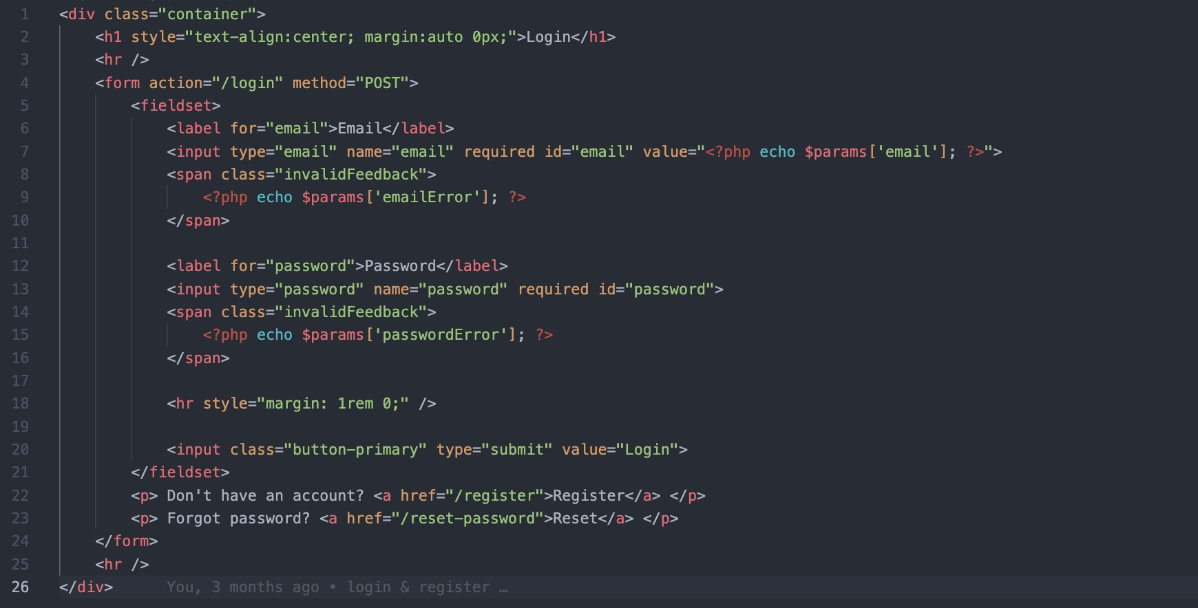

*Figure XXXVIII Login view HTML & PHP code*

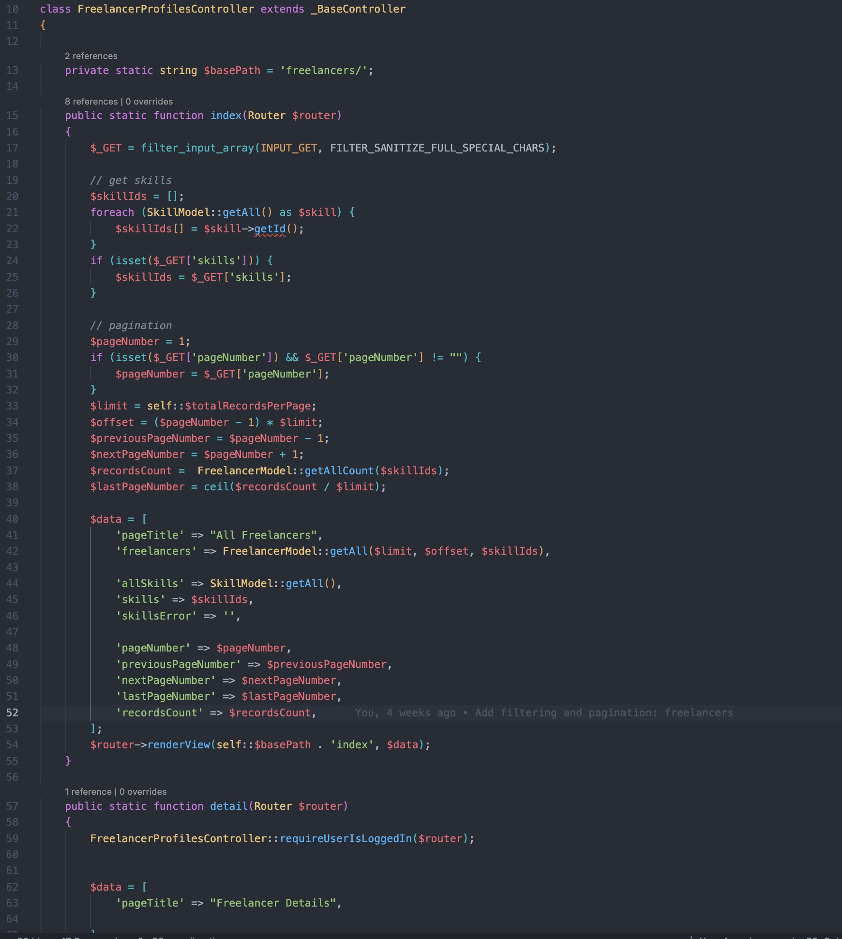

*Figure XXXIX Freelancers controller PHP code*

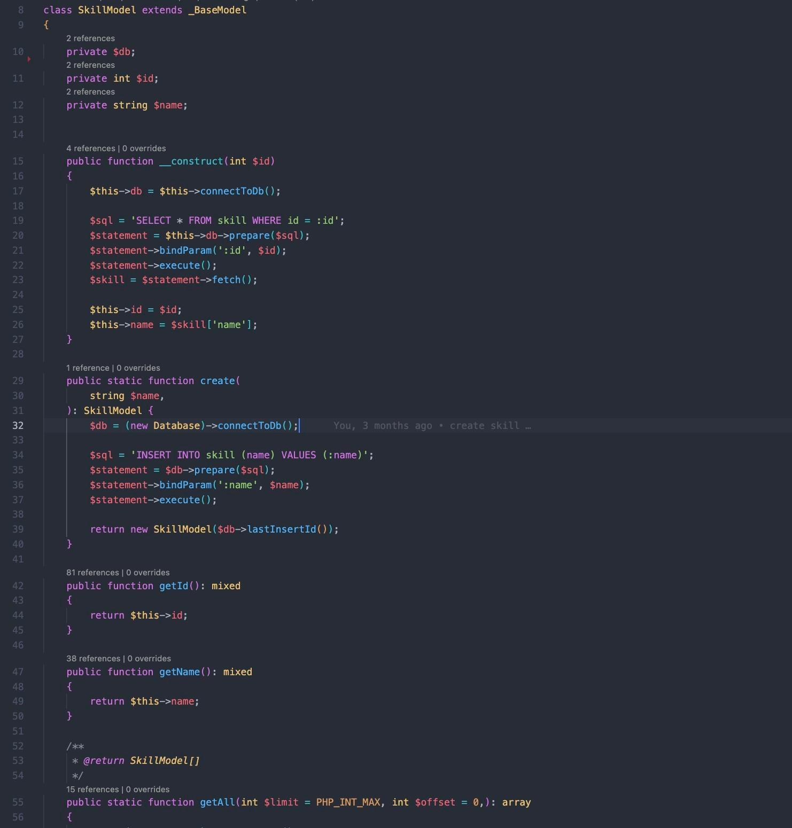

*Figure XL Skill model PHP code*